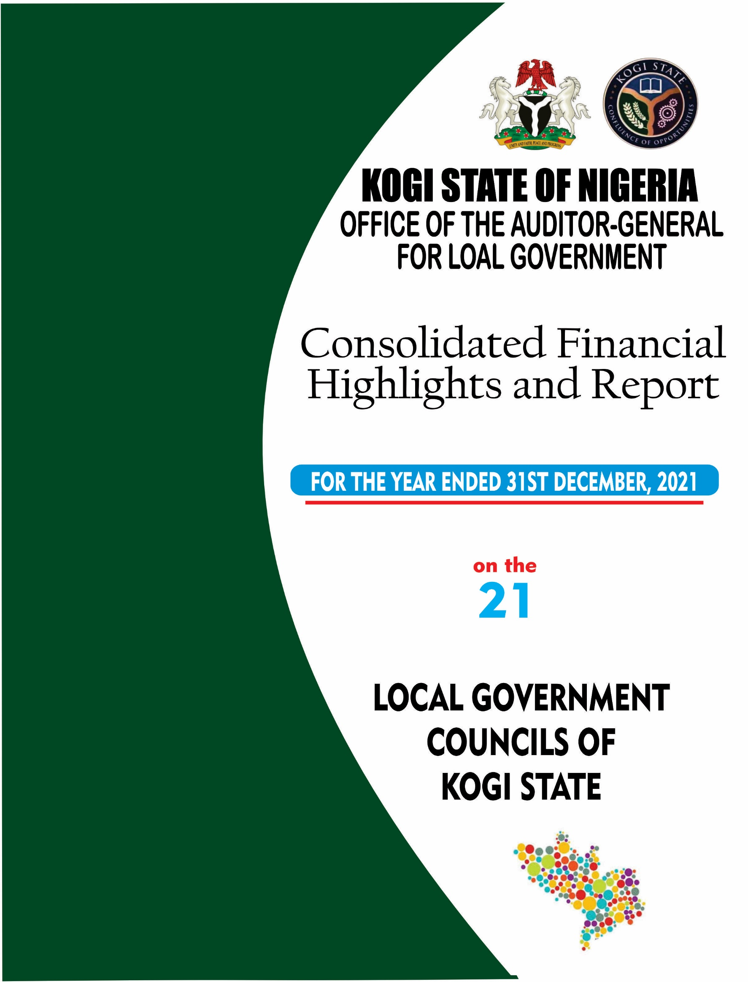

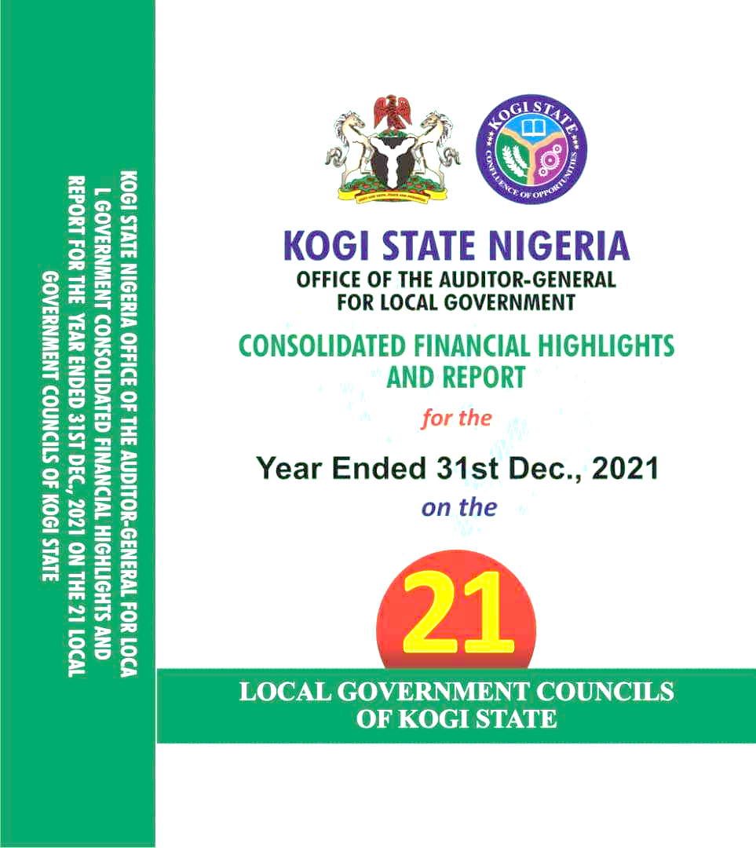

**CONSOLIDATED FINANCIAL HIGHLIGHTS**

**AND REPORT**

**Year Ended 31st Dec., 2021**

**for the**

**On the**

by

JUNE, 2022

Alh. Ahmed Usman Ododo B.Sc., ACA, CPFA, MNIN

*The Auditor-General*

*for Local Government,*

*Kogi State.*

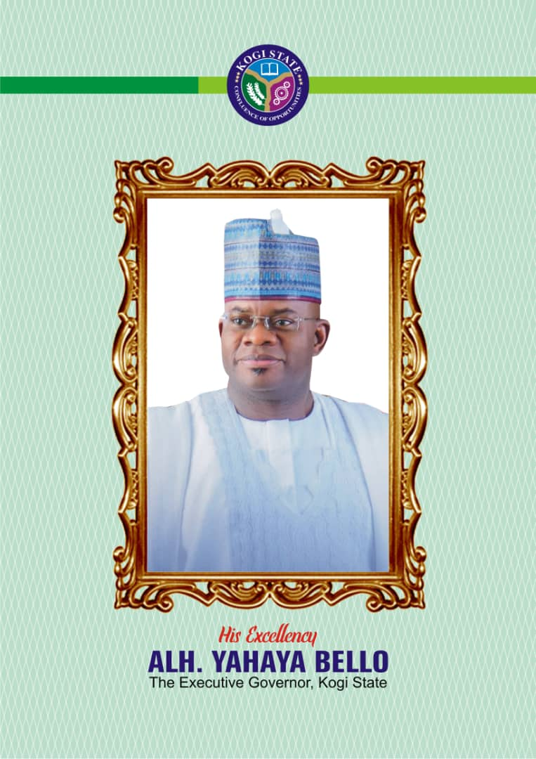

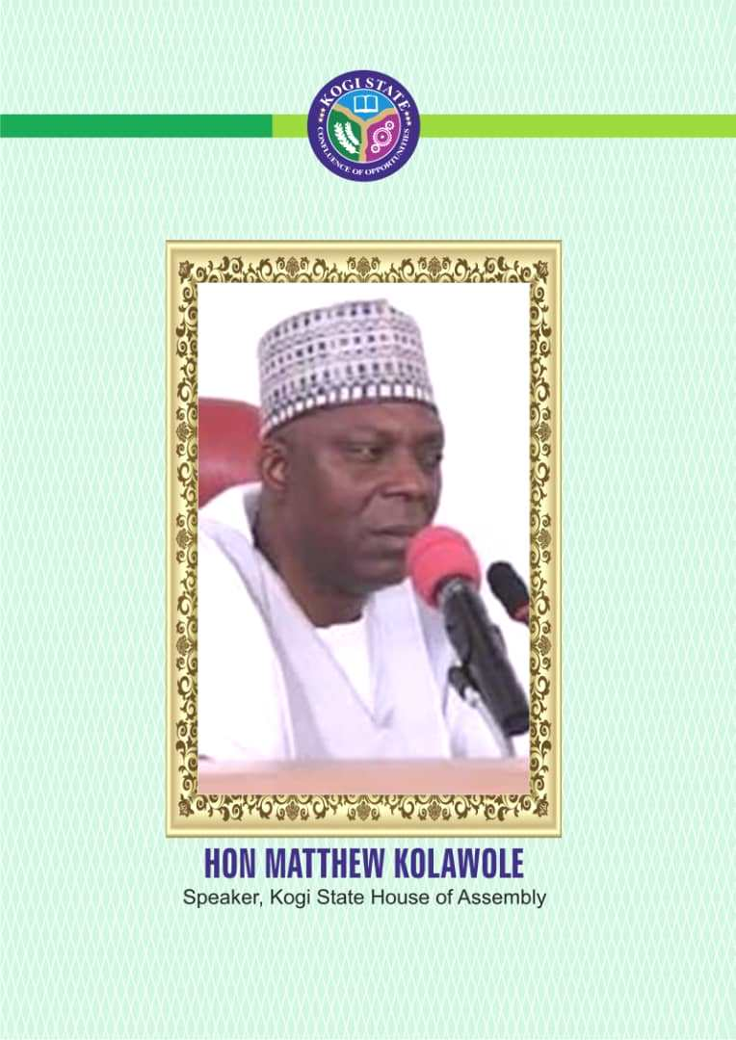

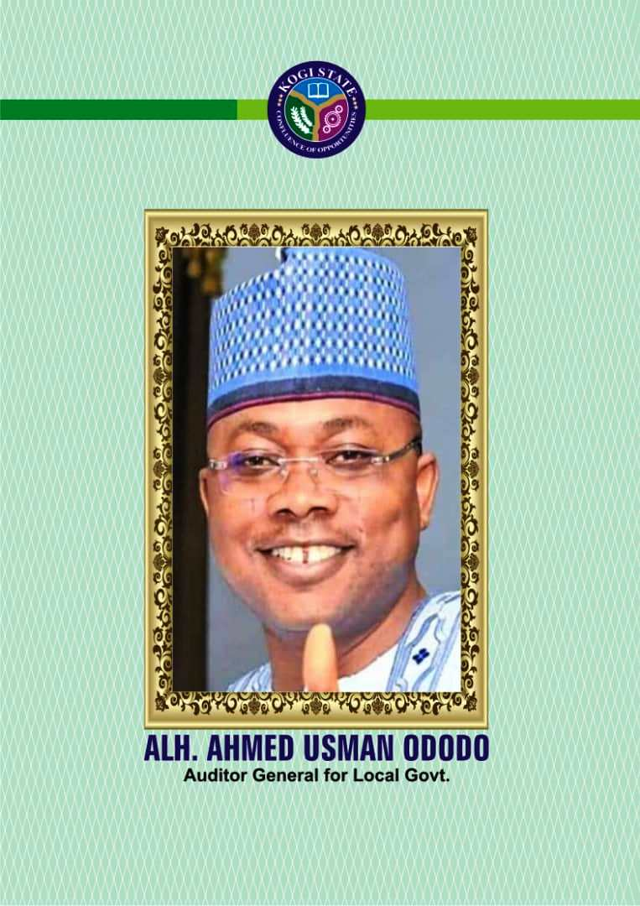

**CONTENTS PAGES**

**Report of the Auditor-General for Local Government** ii-vi

**CHAPTER ONE: Consolidated General Purpose Financial**

**Statements of the 21 Local Government**

**Council for the Year Ended 31st December, 2021** 1

**CHAPTER TWO: Overview of the Consolidated Local Government**

**Council Financial and Implications** 18

**CHAPTER THREE: Conclusion and General Recommendations** 26

**ACKNOWLEDGEMENT**

My never-ending gratitude goes to the Almighty God without whom nothing can be done on the surface of this earth.

I will also remain grateful and indebted to His Excellency, Alhaji Yahaya Adoza Bello, the Executive Governor of Kogi State for finding me worthy of service to the state.

I will not forget the contribution of Mr. Chris Emmanuel, Director of Audit Services, other Directors and my staff who tirelessly coordinated, compiled and produced this document (the 2021 General Purpose Financial Statements of the 21 local government councils and its highlight).

The independent auditors whose independent opinion added value to this document, I also appreciate them for their timely and professional contributions to the success of this work.

Last but not the least is Hon. Matthew Kolawole, the speaker of Kogi State House of Assembly, the Public Account Committee chairman, and his members are grossly appreciated for their legislative support to Office of Auditor General for Local Government.

Thanks, and God bless you all.

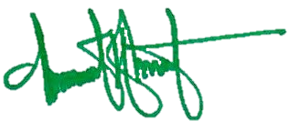

**Alh. Ahmed Usman Ododo B.Sc., ACA, CPFA, MNIN**

*The Auditor-General*

*for Local Government,*

*Kogi State.*

**REPORT OF THE AUDITOR-GENERAL FOR LOCAL GOVERNMENT ON THE TWENTY- ONE (21) LOCAL GOVERNMENT COUNCILS OF KOGI STATE GENERAL PURPOSE FINANCIAL STATEMENTS FOR THE YEAR ENDED 31ST DECEMBER, 2021.**

**REPORT BACKGROUND**

The report was premised on derivable from the analysis of both financial and non-financial information of all the 21 local governments councils of Kogi State in the assessment and evaluation of their performance vis-à-vis implications on the economy of the State and the welfare of people residing in these local governments.

Cumulatively and comparatively, the consolidated financial statement was analysed and interpreted to ascertain the performance of the 21 local governments councils in terms of revenue generation, specifically internally generated revenue, expenditure on provision and maintenance of public amenities as well as how efficient and effective assets and funds employed were used to deliver goods and services to their citizenries (Internal control).

**STATEMENT OF FINANCIAL RESPONSIBILITIES AND RESPONSIBILITIES FOR FINANCIAL STATEMENT.**

These Financial Statements have been prepared by Treasurers of the 21 Local Government Councils as consented to by their various management in compliance with the provision of Financial (Council and Management) Act 1958 as amended. Then consolidated for the purpose of this reportage in accordance with the International Public Sector Accounting Standard (IPSAS) and Financial Reporting Council (FRC) by Office of the Auditor-General for Local Government.

The Treasurers are responsible for establishing and maintaining a system of internal control designed to provide reasonable assurance that the transactions recorded are within statutory authority and properly recorded the use of all public financial resources by the Local Government Councils.

The Treasurers of the 21 local government Councils are responsible for the integrity of this financial statements, the information they contained and their compliances with the extant financial regulations, to reflect fairly the financial position for their local government councils for the year ended 31st December, 2021. Attached to this report is an acknowledgement letter of responsibility by the treasurer, the head of local government administration (HLGA) and the chairman of the local government councils.

**Alh. Ahmed Usman Ododo B.Sc., ACA, CPFA, MNIN**

The Auditor-General

for Local Government,

Kogi State.

**RESPONSIBILITY OF THE AUDITOR-GENERAL**

**PERIOD: 1ST JANUARY, 2021 – 31ST DECEMBER, 2021**

In compliance with Section 125, Subsection 2 of 1999 Constitution and Kogi State Local Government Law 2021 as amended, the Auditor-General for Local Government is to audit and certified the accounts of the 21 local governments councils and report accordingly to the House of Assembly.

Consequently, forwarded for your consideration are the highlight and or exceptions so observed on the consolidated 2021 General Purpose Financial Statements (GPFS) of the 21 local government councils of Kogi State.

**ACCOUNTING BASIS**

The Local Government Councils financial statements used in this report were prepared in accordance with International Public Sector Accounting Standards (IPSAS) on Accrual Basis System of Accounting.

**STATEMENT OF ACCOUNTING POLICIES**

The consolidated financial statements of the 21 local government councils of Kogi State is analyzed and reported upon on the basis of IPSAS Accrual, relevant extant rules and Financial Reporting Council.

**RECEIPTS/REVENUE ACCOUNT**

Non exchange transaction revenue present various allocations from the federation account like Statutory Revenue Account Allocation (SRA), Value Added Tax Allocation, Excess Crude Allocation, Exchange Differential etc. While the Revenue from exchange transactions are the various internally generated revenue expected of local government council to generate as encapsulated in the 1999 constitution, Schedule 4.

**REVALUATION OF LOCAL GOVERNMENT COUNCIL NON CURRENT ASSETS**

In reference to IPSAS 17, noncurrent assets of the 21 local government council were recognized, also revalued by a register valuer for the whole 21 local governments councils to set a standard and a base for subsequent book keeping.

**INTERNAL CONTROL**

Contrary to Chapter 45 of the IPSAS Financial Memoranda (2014), the internal control machinery of the 21 local governments councils is poor and weak, this has tremendously affected the work in progress of office of the Auditor General for Local Government.

**REPORT STRUCTURE**

The structure of this report is basically categorized into three chapters. These are:

**Chapter One:** Consolidated General Purpose financial Statements for the year

ended 31st December, 2021

**Chapter Two:** Overview of the 21 local government councils consolidated

financials and implications

**Chapter Three:** Conclusion and General Recommendations

**Audit Certificate**

The consolidated General Purpose Financial Statement of the 21 local government councils for the year ended 31st December, 2021 as presented by the local government treasurers in accordance with relevant statutory provision as earlier stated, having been examined, in reference to the relevant books of account that inform the content of the financial statements made available to my office, and consequent technical observations therein. I opine that the financial statements and accompanying notes to the accounts of these local government councils are a true and fair view of the stated financial activities of these councils as at 31st December, 2021.



**Alh. Ahmed Usman Ododo B.Sc., ACA, CPFA, MNIN**

The Auditor-General

for Local Government,

Kogi State.

FRC/2019/ICAN/00000019033



|  |  |  |  |  |  |  |
| --- | --- | --- | --- | --- | --- | --- |
| Consolidated Financial Statements | | | | | | |
| On the Accounts of the 21 Local Government Council | | | | | | |
| Of Kogi State for the Year Ended 31st December, 2021 | | | | | | |
| Statements of Financial Performance | | | | | | |
|  | | | | | | |
|  | | **Notes** | **Year Ended 31st December, 2021** | | **Year Ended 31st December, 2020** | |
| REVENUE | |  |  | | | |
|  | Government Share of FAAC (Statutory Revenue) | 1 | 39,844,340,021 | | 30,626,288,823 | |
| Government Share of VAT | 2 | 13,950,886,652 | | 10,009,968,817 | |
| Tax Revenue | 3 | 719,648,043 | | 436,214,901 | |
| Non-Tax Revenue |  | - | | - | |
|  | Aids and Grants |  | - | | - | |
|  | Interest Earned |  | - | | - | |
| TOTAL REVENUE | |  | **54,514,874,716** | | **41,072,472,541** | |
|  | | | |  | |  |
| EXPENDITURES | |  |  | |  | |
|  | Salaries & Wages | 4 | 12,994,716,489 | | 14,406,926,681 | |
| Social Benefits | 5 | 10,598,565,853 | | 6,469,747,111 | |
| Overhead Cost | 6 | 20,397,810,036 | | 17,437,134,748 | |
| Depreciation Charges | 7 | 4,678,320,771 | | 6,134,354,327 | |
| Impairment (Loss) on Investment |  | - | |  | |
| TOTAL EXPENDITURES | |  | **48,669,413,149** | | **44,448,162,867** | |
|  | | | |  | |  |
| Surplus/(Deficit) from Operating Activities for the Period | |  | **5,845,413,567** | | **(3,375,690,326)** | |
|  | Public Debt Charges | 8 | (16,781,398) | | (289,371,794) | |
| Total Non-Operating Revenue/(Expenses) | |  | **5,828,680,169** | | **(3,665,062,120)** | |
| Surplus/(Deficit) from Ordinary Activities | |  | **5,828,680,169** | | **(3,665,062,120)** | |
| Net Surplus/ (Deficit) for the Period | |  | **5,828,680,169** | | **(3,665,062,120)** | |

|  |  |  |  |  |  |
| --- | --- | --- | --- | --- | --- |
| Consolidated Financial Statements | | | | | |
| On the Accounts of the 21 Local Government Council | | | | | |
| Of Kogi State for the Year Ended 31st December, 2021 | | | | | |
| Statement of Financial Position | | | | | |
|  | | | | | |
| ASSETS | **Notes** | **Year Ended 31st December, 2021** | | **Year Ended 31st December, 2020** | |
|  |  |  |  |  |
| Current Assets |  |  |  |  |  |
| Cash and Cash Equivalents | 9 | 198,271,552 |  | 439,761,999 |  |
| Receivables |  |  |  |  |  |
| Other Current Assets |  |  |  |  |  |
| Total Current Assets |  |  | 198,271,552 |  | 439,761,999 |
|  | | | | | |
| Non-Current Assets |  |  |  |  |  |
| Long Term Loans |  | - |  | - |  |
| Investments |  |  |  |  |  |
| Property, Plant & Equipment | 10 | 92,137,635,135 |  | 93,812,350,170 |  |
| Intangible Assets |  |  |  |  |  |
| Total Non-Current Assets |  |  | **92,137,635,135** |  | **93,812,350,170** |
|  | | | | | |
| Total Assets |  |  | **92,335,906,687** |  | **94,252,112,169** |
|  | | | | | |
| LIABILITIES |  |  |  |  |  |
| Current Liabilities |  |  |  |  |  |
| Short Term Loans & Debts |  |  |  |  |  |
| Account Payables | 11 | 92,964,397,262 |  | 81,692,683,802 |  |
| Payables |  |  |  |  |  |
| Total Current Liabilities |  |  | **92,964,397,262** |  | **81,692,683,802** |
|  | | | | | |
| Non-Current Liabilities |  |  |  |  |  |
| Long Term Borrowings |  | - |  | - |  |
| Total Non-Current Liabilities |  |  | **-** |  | **-** |
|  | | | | | |
| Total Liabilities |  |  | **9,294,397,262** |  | **81,692,683,802** |
|  | | | | | |
| Net Assets |  |  | **(628,490,575)** |  | **12,559,428,367** |
|  | | | | | |
| NET ASSETS/EQUITY |  |  |  |  |  |
| Reserves | 12 | (6,457,170,744) |  | 16,224,490,487 |  |
| Accumulated Surpluses/(Deficits) |  | 5,828,680,169 |  | (3,665,062,120) |  |
| Total Net Assets/Equity |  |  | **(628,490,575)** |  | **12,559,428,367** |

|  |  |  |  |
| --- | --- | --- | --- |
| Consolidated Financial Statements | | | |
| On the Accounts of the 21 Local Government Council | | | |
| Of Kogi State for the Year Ended 31st December, 2021 | | | |
| Statement of Change in Assets/Equity | | | |
|  | | | |
| Description | **Reserves** | **Accumulated  Surpluses/ (Deficits)** | **Total** |
| Closing Balance 31st December 2020 | **16,224,490,487** | **(3,665,062,120)** | **12,559,428,367** |
| Credit Transactions | - |  |  |
| Debit Transactions | - |  |  |
| Net Surplus/Deficit |  |  |  |
| Opening Balance as at 01 January 2021 | **16,224,490,487** | **(3,665,062,120)** | **12,559,428,367** |
| Credit Transactions | - | - | - |
| Debit Transactions | - | - | - |
| Net Surplus/(Deficit) | - | 5,828,680,169 | 5,828,680,169 |
| Reserves | (6,457,170,744) | - | (6,457,170,744) |
| Closing Balance as at 31 December 2019 | **(6,457,170,744)** | **5,828,680,169** | **(628,490,577)** |

|  |  |  |  |
| --- | --- | --- | --- |
| Consolidated Financial Statements | | | |
| On the Accounts of the 21 Local Government Council | | | |
| Of Kogi State for the Year Ended 31st December, 2021 | | | |
| Statement of Cashflow | | | |
|  | | | |
| Description | **Notes** | **Year Ended 31st December, 2021** | **Year Ended 31st December, 2020** |
| CASH FLOWS FROM OPERATING ACTIVITIES |  |  |  |
| Inflows |  |  |  |
| Government Share of FAAC (Statutory Revenue) | 1 | 39,844,340,021 | 30,626,288,823 |
| Government Share of VAT | 2 | 13,950,886,652 | 10,009,968,817 |
| Tax Revenue | 3 | 719,648,043 | 436,214,901 |
| Non-Tax Revenue |  | - | - |
| Total Inflow From Operating Activities |  | **54,514,874,716** | **41,072,472,541** |
|  |  |  |  |
| Expenditure (Outflows): |  |  |  |
| Salaries & Wages | 4 | (5,247,562,880) | (7,382,538,545) |
| Social Benefits | 5 | (4,352,426,494) | (5,300,695,206) |
| Overhead Cost(s) | 6 | (20,397,810,036) | (17,437,134,748) |
| Finance Cost (Bank Charges) | 8 | (4,679,320,771) | (6,134,354,327) |
| Total Outflow From Operating Activities |  | **(34,677,120,181)** | **(36,254,722,826)** |
| Net Cash Flow From Operating Activities |  | **19,837,754,535** | **4,817,749,715** |
|  |  |  |  |
| CASH FLOWS FROM INVESTING ACTIVITIES |  |  |  |
| Purchase/Construction/Rehabilitation of PPE | 13 | (13,999,906,787) | (11,277,116,286) |
| Purchase/ Construction of Investment Property |  | - | - |
| Purchase of Intangible Assets |  | - | - |
| Acquisition of Investments |  | - | - |
| Dividends Received |  | - | - |
| Net Cash Flow From Investment Activities |  | **(13,999,906,787)** | **(11,277,116,286)** |
| Cash Flow From Financing Activities |  |  |  |
| Proceeds from Borrowing:- Long Term Loan |  | - | - |
| Distribution of Surplus/Dividends paid |  | - | - |
| Net Cash Flow From Financing Activities |  | - | - |
| Net Cash Flow From All Activities |  | **5,837,847,748** | **(6,459,366,571)** |
| Open Cash Balance as @ 1/1/2021 |  | **439,761,999** |  |
| Closing Cash balance as at 31/12/2021 |  | **198,271,552** | **439,761,999** |

|  |  |  |
| --- | --- | --- |
| Consolidated Statements of Reconciliation of Net Surplus(Deficit) To Net Cash flow from Operating Activities | | |
| On the Accounts of the 21 Local Government Council | | |
| Of Kogi State for the Year Ended 31st December, 2021 | | |
|  | | |
|  | | |
| Description | **Notes** | **Year Ended 31st Dec 2021** |
| Net Surplus/(Deficit) as per Statement of Financial Performance |  | 5,828,680,169 |
| Add/(Less) non-cash items |  |  |
| Depreciation and Amortisation |  | 4,678,320,771 |
| Impairment of Investments |  |  |
| *Total non-cash Items* |  | ***10,507,000,940*** |
|  | | |
| Add/(Less) movements in statement of financial position items |  |  |
| Increase/(Decrease) in Short Term Loan (Proceeds from Borrowing) |  | - |
| Increase/(Decrease) in Long Term Loan (Proceeds from Borrowing) |  | - |
| (Increase)/decrease in Loan Repayment |  | - |
| *Total movements in working capital items* |  | ***-*** |
|  | | |
| Add/(Less) items classified as investing activities |  |  |
| Purchase of PPE | 14 | (13,999,906,787) |
| *Total items classified as investing activities* |  | ***(13,999,906,787)*** |
|  | | |
| Net cash flow from All (Operating) Activities |  | ***5,837,847,748*** |
| Cash & Cash Equivalent as at 01 January 2019 | **439,761,999** |
| Cash & Cash Equivalent as at 31 December 2019 | **198,271,552** |

**Note to the Consolidated Financial Statement**

**Note 1: Share Of FAAC (Statutory Allocation) 2021**

|  |  |  |  |
| --- | --- | --- | --- |
| No | Local Governments | Year Ended 31st December, 2021 | Year Ended 31st December, 2020 |
| 1 | Adavi L. G | 1,475, 764, 960 | 1 ,524, 404, 436 |
| 2 | Ajaokuta L. G | 1, 299 642, 634 | 1, 356, 311, 512 |
| 3 | Ankpa L. G | 1, 650, 568, 509 | 1, 624, 455, 419 |
| 4 | Bassa L. G | 11,780,324,336 | 1, 360, 970, 176 |
| 5 | Dekina L. G | 1, 794, 425, 992 | 1, 869, 894, 699 |
| 6 | Ibaji L. G | 1,377, 479,566 | 1, 492, 630, 273 |
| 7 | Idaji L. G | 1, 145, 3457, 103 | 1, 254, 289, 715 |
| 8 | Igalamela-Odolu L. G | 1, 410, 527, 028 | 1, 476, 106, 909 |
| 9 | Ijumu L. G | 1, 237, 834, 526 | 1, 291, 341, 930 |
| 10 | Kabba –Bunu L. G | 1, 591, 761, 829 | 1, 560, 368, 556 |
| 11 | Kogi L. G | 1, 237, 834, 526 | 1, 291, 341, 930 |
| 12 | Lokoja L. G | 1, 591, 761, 829 | 1, 560, 368, 556 |
| 13 | Mopa Muro L. G | 1, 035, 089, 009 | 1, 081, 089, 209 |
| 14 | Ofu L.G | 1, 520,645, 650 | 1, 574, 342, 408 |
| 15 | Ogori-Magongo L. G | 1, 000, 900, 067 | 1, 100, 755, 530 |
| 16 | Okehi L. G | 1, 478, 412, 358 | 1, 539, 954, 156 |
| 17 | Okene L. G | 1, 856, 865, 838 | 1, 936, 706, 500 |
| 18 | Olamaboro L.G | 1, 391, 317, 701 | 1, 454, 837, 936 |
| 19 | Omala L.G | 1, 315, 021, 302 | 1, 363, 309, 564 |
| 20 | Yagba East L. G | 1, 413, 332, 972 | 1, 474,763, 371 |
| 21 | Yagba-West L. G | 1, 385, 737, 493 | 1, 459, 776, 071 |
|  | **Grand Total** | **39, 844, 340 021** | **30, 626, 288, 823** |

**Note to the Consolidated Financial Statement**

**Note 2: Share Of Value Added Tax (Vat) 2021**

|  |  |  |  |
| --- | --- | --- | --- |
| No | Local Governments | Year Ended 31st December, 2021 | Year Ended 31st December, 2020 |
| 1 | Adavi L. G | 732, 041 , 445 | 524, 960, 503 |
| 2 | Ajaokuta L. G | 618, 711, 445 | 442, 675, 388 |
| 3 | Ankpa L. G | 824, 477, 953 | 591, 978, 546 |
| 4 | Bassa L. G | 590, 774, 635 | 460, 974, 303 |
| 5 | Dekina L. G | 814, 488, 236 | 601, 166, 039 |
| 6 | Ibaji L. G | 632, 953, 604 | 408, 771, 990 |
| 7 | Idah L. G | 558, 405, 319 | 401, 070, 126 |
| 8 | Igalamela-Odolu L. G | 653, 172, 289 | 469, 331, 750 |
| 9 | Ijumu L. G | 625, 317, 719 | 443, 709, 881 |
| 10 | Kabba –Bunu L. G | 651, 520, 384 | 466, 583, 717 |
| 11 | Kogi L. G | 609, 601, 508 | 436, 190, 205 |
| 12 | Lokoja L. G | 722, 196, 237 | 517, 827, 634 |
| 13 | Mopa Muro L. G | 507,644, 691 | 362, 265, 852 |
| 14 | Ofu L.G | 707, 809, 410 | 514, 646, 942 |
| 15 | Ogori-Magongo L. G | 501, 380, 837 | 357, 724, 210 |
| 16 | Okehi L. G | 728, 918, 353 | 522, 701, 741 |
| 17 | Okene L. G | 899, 540, 632 | 646, 412, 185 |
| 18 | Olamaboro L.G | 672, 390, 899 | 481, 711, 551 |
| 19 | Omala L.G | 598, 965, 599 | 427, 877, 129 |
| 20 | Yagba East L. G | 656, 595, 311 | 470, 253, 321 |
| 21 | Yagba-West L. G | 644, 007, 096 | 461, 135, 804 |
|  | **Grand Total** | **13,950,886,652** | **10, 009,968,817** |

**Note to the Consolidated Financial Statement**

**Note 3: Tax Revenue And Non Tax Revenue**

|  |  |  |  |  |
| --- | --- | --- | --- | --- |
| No | Local Governments | Ranking | Year Ended 31st December, 2021 | Year Ended 31st December, 2020 |
| 1 | Adavi L. G | 18th | 25, 830, 908 | 3, 511, 557 |
| 2 | Ajaokuta L. G | 11th | 29, 828, 224 | 17, 221, 586 |
| 3 | Ankpa L. G | 4th | 44, 678, 630 | 48, 380, 191 |
| 4 | Bassa L. G | 7th | 36, 036, 794 | 11, 703, 860 |
| 5 | Dekina L. G | 1st | 65, 817, 485 | 25, 988, 513 |
| 6 | Ibaji L. G | 5th | 39, 104, 460 | 24, 657, 634 |
| 7 | Idah L. G | 21st | 15, 861, 415 | 25, 207, 276 |
| 8 | Igalamela-Odolu L. G | 16th | 27, 397, 633 | 16, 616, 301 |
| 9 | Ijumu L. G | 12th | 29, 038, 759 | 38, 910, 013 |
| 10 | Kabba –Bunu L. G | 10th | 31, 372, 418 | 18, 145, 700 |
| 11 | Kogi L. G | 8th | 36, 036, 914 | 19, 363, 900 |
| 12 | Lokoja L. G | 2nd | 54, 334, 043 | 48, 436, 002 |
| 13 | Mopa Muro L. G | 19th | 25, 103, 538 | 22, 564, 671 |
| 14 | Ofu L.G | 20th | 23, 162, 815 | 8, 050, 992 |
| 15 | Ogori-Magongo L. G | 17th | 25, 942, 687 | 11, 544, 854 |
| 16 | Okehi L. G | 15th | 28, 353, 505 | 7, 920, 750 |
| 17 | Okene L. G | 3rd | 52, 959, 231 | 25, 681, 046 |
| 18 | Olamaboro L.G | 9th | 34, 428, 706 | 12, 046, 860 |
| 19 | Omala L.G | 13th | 29, 026, 685 | 14,034,143 |
| 20 | Yagba East L. G | 6th | 36, 767, 566 | 23, 635, 338 |
| 21 | Yagba-West L. G | 14th | 28, 565, 627 | 12, 593, 714 |
|  | **Grand Total** |  | **719, 648, 043** | **436, 214, 901** |

**Note to the Consolidated Financial Statement**

**Note 4: Salaries And Wages**

|  |  |  |  |  |  |
| --- | --- | --- | --- | --- | --- |
| No | Local Governments | Year Ended 31st December, 2021 | | Year Ended 31st December, 2020 | |
|  |  | **Performance** | **Cash Flow** | **Performance** | **Cash Flow** |
| 1 | Adavi L. G | 807, 624, 613 | 323, 049, 845 | 340, 044, 080 | 340, 044, 080 |
| 2 | Ajaokuta L. G | 801,059,902 | 288, 107, 953 | 814, 135, 357 | 321, 853, 234 |
| 5 | Ankpa L. G | 749, 472, 601 | 309, 723, 483 | 796, 993, 060 | 308, 108, 552 |
| 4 | Bassa L. G | 558, 256, 090 | 223, 302, 436 | 673, 992, 807 | 262, 525, 983 |
| 5 | Dekina L. G | 597, 867, 366 | 244, 991, 385 | 690 308, 772 | 283, 983, 040 |
| 6 | Ibaji L. G | 665, 743, 645 | 260, 946, 545 | 604, 266, 684 | 604, 266, 684 |
| 7 | Idah L. G | 676, 720, 807 | 290, 943, 781 | 498, 345, 044 | 242, 183, 995 |
| 8 | Igalamela-Odolu L. G | 608, 883, 375 | 250, 317, 948 | 581, 278, 714 | 447, 950, 590 |
| 9 | Ijumu L. G | 759, 571, 660 | 255, 034, 036 | 579, 015, 569 | 579, 015, 569 |
| 10 | Kabba –Bunu L. G | 673, 861, 713 | 259, 531, 437 | 631, 828, 082 | 248, 697, 053 |
| 11 | Kogi L. G | 635, 038, 421 | 282, 458, 320 | 883, 834, 601 | 265, 382, 841 |
| 12 | Lokoja L. G | 475, 323, 287 | 202, 089, 962 | 1, 692, 056, 026 | 199, 134, 909 |
| 13 | Mopa Muro L. G | 443, 289, 443 | 211, 561, 326 | 937, 195, 109 | 309, 328, 887 |
| 14 | Ofu L.G | 540, 776, 261 | 222, 606, 662 | 560, 694, 424 | 504 694, 424 |
| 15 | Ogori-Magongo L. G | 393, 669, 324 | 142, 430, 775 | 343, 024, 952 | 172, 925, 337 |
| 16 | Okehi L. G | 635, 413, 266 | 246, 533, 595 | 679, 078, 333 | 316, 957, 555 |
| 17 | Okene L. G | 589, 264, 401 | 230, 703, 418 | 524, 836, 507 | 224, 011, 977 |
| 18 | Olamaboro L.G | 510, 734, 224 | 219, 100, 556 | 556, 104, 729 | 250, 744, 979 |
| 19 | Omala L.G | 575, 495, 502 | 266, 124, 361 | 422, 360, 085 | 211, 180, 429 |
| 20 | Yagba East L. G | 585, 361, 733 | 241, 286, 139 | 559, 483, 267 | 250, 951, 938 |
| 21 | Yagba-West L. G | 712, 388, 855 | 276,718,917 | 1, 038,596,489 | 1, 038,596,489 |
|  | **Grand Total** | **12,994,716,489** | **5,247,562,880** | **14,406,926,281** | **7,382,538,545** |

**Note to the Consolidated Financial Statement**

**Note 5: Social Benefit (Monthly Pension Payment)**

|  |  |  |  |  |  |
| --- | --- | --- | --- | --- | --- |
| No | Local Governments | Year Ended 31st December, 2021 | | Year Ended 31st December, 2020 | |
|  |  | **Performance** | **Cash Flow** | **Performance** | **Cash Flow** |
| 1 | Adavi L. G | 538,673,772 | 323,049,845 | 319,379, 869 | 340,344,080 |
| 2 | Ajaokuta L. G | 214,927,871 | 80,506,600 | 197,863,013 | 90,076,678 |
| 3 | Ankpa L. G | 797,916,803 | 297,717,050 | 310,362, 199 | 310,362,199 |
| 4 | Bassa L. G | 341,300,389 | 135,720,155 | 138,009,333 | 138,009,333 |
| 5 | Dekina L. G | 947,257,349 | 349,513,653 | 911,320,304 | 340,532,031 |
| 6 | Ibaji L. G | 226,663,262 | 113,331,631 | 110,515,747 | 110,515,747 |
| 7 | Idah L. G | 262,703,445 | 131,351,723 | 149,544,199 | 149,544,199 |
| 8 | Igajame- Odolu L. G | 542,843,147 | 189,995,101 | 184,210,004 | 184,210,004 |
| 9 | Ijumu L. G | 626,666,754 | 313,333,377 | 736,221,637 | 736,221,637 |
| 10 | Kabba –Bunu L. G | 750,741,244 | 263,247,500 | 287,374,523 | 287,374,523 |
| 11 | Kogi L. G | 227,571,218 | 91,028,487 | 89,818,534 | 89,818,534 |
| 12 | Lokoja L. G | 598,716,788 | 264,297,678 | 737,624,450 | 287,207,706 |
| 13 | Mopa Muro L. G | 311,803,016 | 116,477,116 | 116,206,031 | 116,206,031 |
| 14 | Ofu L.G | 528,735,779 | 222,606,662 | 210,932,293 | 504,694,424 |
| 15 | Ogori-Magongo L. G | 193,097,352 | 88,395,697 | 95,015,076 | 95,015,076 |
| 16 | Okehi L. G | 551,721,443 | 212,200,555 | 242,693,944 | 242,693,944 |
| 17 | Okene L. G | 1,003,670,358 | 367,928,685 | 378,917,721 | 378,917,721 |
| 18 | Olamaboro L.G | 492,006,471 | 205,756,566 | 599,856,851 | 248,368,851 |
| 19 | Omala L.G | 333,849,305 | 124,584,028 | 123,557,563 | 123,557,563 |
| 20 | Yagba East L. G | 407,465,539 | 201,932,010 | 228,480,879 | 228,480,878 |
| 21 | Yagba West L.G | 700,234,548 | 259,452,375 | 301,843,941 | 301,843,941 |
|  | **Grand Total** | **10,598,565,853** | **4,352,426,494** | **6,469,747,111** | **5,300,695,206** |

**Note to the Consolidated Financial Statement**

**Note 6: Over Head Cost**

|  |  |  |  |  |
| --- | --- | --- | --- | --- |
| No | Local Governments | Ranking | Year Ended 31st December, 2021 | Year Ended 31st December, 2020 |
| 1 | Adavi L. G | 16th | 842, 792, 565 | 189, 171, 511 |
| 2 | Ajaokuta L. G | 10th | 1, 012, 236, 370 | 931, 278, 392 |
| 3 | Ankpa L. G | 9th | 1, 029, 193, 209 | 1, 010, 086, 708 |
| 4 | Bassa L. G | 19th | 687, 632, 022 | 639, 558, 836 |
| 5 | Dekina L. G | 1st | 1, 598, 083, 303 | 1, 192, 386, 098 |
| 6 | Ibaji L. G | 20th | 538, 143, 064 | 955, 119, 502 |
| 7 | Idah L. G | 17th | 778, 163, 510 | 641, 213, 253 |
| 8 | Igajame- Odolu L. G | 12th | 969, 233, 675 | 580, 885, 425 |
| 9 | Ijumu L. G | 15th | 868, 177, 817 | 913,573, 922 |
| 10 | Kabba –Bunu L. G | 18th | 711, 163, 737 | 775, 687, 474 |
| 11 | Kogi L. G | 14th | 932, 379, 188 | 817, 863, 122 |
| 12 | Lokoja L. G | 7th | 1,064, 136, 571 | 1,131, 803, 270 |
| 13 | Mopa Muro L. G | 21st | 511, 739, 340 | 307, 583, 017 |
| 14 | Ofu L.G | 2nd | 1, 337, 624, 940 | 890, 667, 518 |
| 15 | Ogori-Magongo L. G | 5th | 1,101, 019, 252 | 970, 040, 272 |
| 16 | Okehi L. G | 6th | 1 089, 718 191 | 978, 888, 255 |
| 17 | Okene L. G | 3rd | 1, 203, 431, 126 | 1,172, 517, 225 |
| 18 | Olamaboro L.G | 11th | 993,339, 078 | 961, 515, 844 |
| 19 | Omala L.G | 4th | 1,122, 650, 915 | 950, 687, 491 |
| 20 | Yagba East L. G | 13th | 967,435, 151 | 899, 390, 590 |
| 21 | Yagba-West L. G | 8th | 1,039, 516, 739, | 527, 217, 027 |
|  | **Grand Total** |  | **20,397, 810, 03** | **17,437,134,748** |

**Note to the Consolidated Financial Statement**

**Note 7: Depreciation Charge:**

|  |  |  |  |
| --- | --- | --- | --- |
| No | Local Governments | Year Ended 31st December, 2021 | Year Ended 31st December, 2020 |
| 1 | Adavi L. G | 328,111,369 | 1,133,243,533 |
| 2 | Ajaokuta L. G | 124,261,479 | 113,039,171 |
| 3 | Ankpa L. G | 316,979,273 | 298,296,381 |
| 4 | Bassa L. G | 156,951,334 | 12,945,855 |
| 5 | Dekina L. G | 690,541,869 | 647,865,569 |
| 6 | Ibaji L. G | 61,548,518 | 161,139,322 |
| 7 | Idah L. G | 102,295,141 | 187,924,411 |
| 8 | Igajame- Odolu L. G | 161,485,273 | 261,365,824 |
| 9 | Ijumu L. G | 117,333,669 | 149,898,270 |
| 10 | Kabba –Bunu L. G | 171,458,185 | 289,331,988 |
| 11 | Kogi L. G | 404,043,842 | 413,747,593 |
| 12 | Lokoja L. G | 277,403,417 | 537,679,671 |
| 13 | Mopa Muro L. G | 356,978,847 | 340,331,098 |
| 14 | Ofu L.G | 156,040,756 | 186,342,267 |
| 15 | Ogori-Magongo L. G | 98,460,683 | 103,134,806 |
| 16 | Okehi L. G | 261,337,468 | 212,442,017 |
| 17 | Okene L. G | 216,606,338 | 205,327,551 |
| 18 | Olamaboro L.G | 243,037,128 | 345,472,916 |
| 19 | Omala L.G | 150,654,260 | 219,085,970 |
| 20 | Yagba East L. G | 119,777,549 | 133,619,786 |
| 21 | Yagba-West L. G | 163,014,373 | 182,123,328 |
|  | **Grand Total** | **4,678,320,771** | **6,134,354,327** |

**Note to the Consolidated Financial Statement**

**Note 8: Public Debt Charge (Bank Charges):**

|  |  |  |  |
| --- | --- | --- | --- |
| No | Local Governments | Year Ended 31st December, 2021 | Year Ended 31st December, 2020 |
| 1 | Adavi L. G | 2,571,468 | 11,978,923 |
| 2 | Ajaokuta L. G | 1,478,293 | 14,506,828 |
| 3 | Ankpa L. G | 145,207 | 20,670,322 |
| 4 | Bassa L. G | 2,647,166 | 12,603,293 |
| 5 | Dekina L. G | 201,408 | 9,709,669 |
| 6 | Ibaji L. G | 77,899 | 11,181,994 |
| 7 | Idah L. G | 1,319,353 | 25,482, 845 |
| 8 | Igajame- Odolu L. G | 39,492 | 13,118,778 |
| 9 | Ijumu L. G | 54,012 | 14,386,529 |
| 10 | Kabba –Bunu L. G | 558,894 | 13,982,433 |
| 11 | Kogi L. G | 685,901 | 12,870,432 |
| 12 | Lokoja L. G | 195,915 | 16,972,522 |
| 13 | Mopa Muro L. G | 380,169 | 10,074,252 |
| 14 | Ofu L.G | 147,339 | 14,037,899 |
| 15 | Ogori-Magongo L. G | 256,943 | 588,419 |
| 16 | Okehi L. G | 95,875 | 15,875,375 |
| 17 | Okene L. G | 1,0166,231 | 22,259,219 |
| 18 | Olamaboro L.G | 909,901 | 13,756,472 |
| 19 | Omala L.G | 422,596 | 7,601,740 |
| 20 | Yagba East L. G | 754,102 | 14,323,546 |
| 21 | Yagba-West L. G | 2,823,234 | 13,390,031 |
|  | **Grand Total** | **16,781,398** | **289,371,794** |

**Note to the Consolidated Financial Statement**

**Note 9: Cash And Cash Equivalent/Other Current Assets:**

|  |  |  |  |
| --- | --- | --- | --- |
| No | Local Governments | Year Ended 31st December, 2021 | Year Ended 31st December, 2020 |
| 1 | Adavi L. G | 6,254,084 | 1,858,542 |
| 2 | Ajaokuta L. G | 3,478,847 | 1,310,006 |
| 3 | Ankpa L. G | 8,536,787 | 6,198,531 |
| 4 | Bassa L. G | 5,982,872 | 8,899,427 |
| 5 | Dekina L. G | 6,536,882 | 13,457,218 |
| 6 | Ibaji L. G | 3,562,007 | 3,508,579 |
| 7 | Idah L. G | 2,815,101 | 2,944,307 |
| 8 | Igajame- Odolu L. G | 3,109,748 | 12,288,750 |
| 9 | Ijumu L. G | 8,102,200 | 8,865,798 |
| 10 | Kabba –Bunu L. G | 10,072,520 | 8,057,620 |
| 11 | Kogi L. G | 1,880,878 | 12,458,696 |
| 12 | Lokoja L. G | 32,969,970 | 17,452,276 |
| 13 | Mopa Muro L. G | 7,633,554 | 6,256,484 |
| 14 | Ofu L.G | 5,025,536 | 202,498,352 |
| 15 | Ogori-Magongo L. G | 45,514,609 | 9,432,272 |
| 16 | Okehi L. G | 3,793,987 | 3,975,67 |
| 17 | Okene L. G | 27,687,140 | 23,383,868 |
| 18 | Olamaboro L.G | 7,565,518 | 58,968,381 |
| 19 | Omala L.G | 1,811,143 | 3,244,266 |
| 20 | Yagba East L. G | 3,981,963 | 29,350,844 |
| 21 | Yagba-West L. G | 1,956,206 | 5,352,106 |
|  | **Grand Total** | **198,271,552** | **439,761,999** |

**Note to the Consolidated Financial Statement**

**Note 10: Non-Current Asset (Net Book Value)**

|  |  |  |  |
| --- | --- | --- | --- |
| No | Local Governments | Year Ended 31st December, 2021 | Year Ended 31st December, 2020 |
| 1 | Adavi L. G | 8,518,477,641 | 8,958,405,436 |
| 2 | Ajaokuta L. G | 2,210,351,709 | 2,136,651,977 |
| 3 | Ankpa L. G | 3,999,766,680 | 4,103,280,521 |
| 4 | Bassa L. G | 2,127,973,788 | 1,424,025,613 |
| 5 | Dekina L. G | 11,804,709,290 | 12,071,689,190 |
| 6 | Ibaji L. G | 2,821,195,382 | 2,955,284,266 |
| 7 | Idah L. G | 2,819,186,141 | 2,915,576,753 |
| 8 | Igajame- Odolu L. G | 3,620,988,512 | 3,816,827,307 |
| 9 | Ijumu L. G | 2,945,627,478 | 3,147,232,919 |
| 10 | Kabba –Bunu L. G | 5,532,962,299 | 5,652,234,957 |
| 11 | Kogi L. G | 6,996,620,754 | 7,346,522,829 |
| 12 | Lokoja L. G | 10,235,448,950 | 10,564,609,095 |
| 13 | Mopa Muro L. G | 4,703,913,565 | 4,837,045,497 |
| 14 | Ofu L.G | 3,441,045,78 | 3,352,682,809 |
| 15 | Ogori-Magongo L. G | 1,978,306,044 | 1,917,284,146 |
| 16 | Okehi L. G | 2,116,664,429 | 2,197,321,229 |
| 17 | Okene L. G | 2,282,927,469 | 2,358,98,807 |
| 18 | Olamaboro L.G | 5,226,032,397 | 5,152,759,125 |
| 19 | Omala L.G | 4,015,831,070 | 4,008,391,074 |
| 20 | Yagba East L. G | 1,580,628,787 | 1,635,152,979 |
| 21 | Yagba-West L. G | 3,158,976,982 | 3,260,377,641 |
|  | **Grand Total** | **92,137,635,135** | **93,812,350,170** |

**Note to the Consolidated Financial Statement**

**Note 11: Account Payable (Liabilities)**

|  |  |  |  |
| --- | --- | --- | --- |
| No | Local Governments | Year Ended 31st December, 2021 | Year Ended 31st December, 2020 |
| 1 | Adavi L. G | 5,706,120,379 | 5,693,442,738 |
| 2 | Ajaokuta L. G | 4,899,999,037 | 4,000,216978 |
| 3 | Ankpa L. G | 5,015,926,834 | 4,576,177,716 |
| 4 | Bassa L. G | 4,039,370,076 | 3,704,41,422 |
| 5 | Dekina L. G | 5,170,349,735 | 4,220,587,057 |
| 6 | Ibaji L. G | 3,525,583,082 | 3,164,279,745 |
| 7 | Idah L. G | 3,489,345,844 | 3,103,468,719 |
| 8 | Igajame- Odolu L. G | 2,322,289,457 | 1,533,358,530 |
| 9 | Ijumu L. G | 3,340,115,084 | 5,079,365 |
| 10 | Kabba –Bunu L. G | 4,309,883,322 | 3,896,549,954 |
| 11 | Kogi L. G | 4,378,227,064 | 3,729,362,115 |
| 12 | Lokoja L. G | 5,836,951,990 | 6,103,110,572 |
| 13 | Mopa Muro L. G | 3,464,751,132 | 3,039,646,989 |
| 14 | Ofu L.G | 6,889,022,628 | 6,676,517,195 |
| 15 | Ogori-Magongo L. G | 3,215,394,223 | 2,944,155,655 |
| 16 | Okehi L. G | 5,942,439,188 | 5,028,478,688 |
| 17 | Okene L. G | 5,833,060,109 | 5,411,910,345 |
| 18 | Olamaboro L.G | 3,794,092,908 | 4,741,853,586 |
| 19 | Omala L.G | 2,547,308,070 | 2,237,936,929 |
| 20 | Yagba East L. G | 2,947,962,350 | 2,494,875,273 |
| 21 | Yagba-West L. G | 6,296,204,750 | 5,387,259,231 |
|  | **Grand Total** | **92,964,397,262** | **81,692,683,802** |

**Note to the Consolidated Financial Statement**

**Note 13: Purchase/Construction/Rehabilitation Of PPE**

|  |  |  |  |
| --- | --- | --- | --- |
| No | Local Governments | Year Ended 31st  December, 2021 | Year Ended 31st  December, 2020 |
| 1 | Adavi L. G | 845,331,384 | 392,018,500 |
| 2 | Ajaokuta L. G | 563,640,097 | 428,833,967 |
| 3 | Ankpa L. G | 882,500,889 | 616,888,290 |
| 4 | Bassa L. G | 758,173,358 | 798,860,007 |
| 5 | Dekina L. G | 488,862,300 | 677,297,849 |
| 6 | Ibaji L. G | 1,137,185,063 | 402,761,639 |
| 7 | Idah L. G | 517,964,544 | 401,933,903 |
| 8 | Igajame- Odolu L. G | 645,820,545 | 680,067,415 |
| 9 | Ijumu L. G | 525,970,592 | 350,667,887 |
| 10 | Kabba –Bunu L. G | 860,044,560 | 634,776,018 |
| 11 | Kogi L. G | 587,498,870 | 358,870,966 |
| 12 | Lokoja L. G | 827,696,035 | 590,455,854 |
| 13 | Mopa Muro L. G | 730,852,235 | 738,750,473 |
| 14 | Ofu L.G | 441,046,468 | 412,541,005 |
| 15 | Ogori-Magongo L. G | 159,482,315 | 199,451,785 |
| 16 | Okehi L. G | 688,803,689 | 607,548,424 |
| 17 | Okene L. G | 1,001,982,968 | 816,468,618 |
| 18 | Olamaboro L.G | 708,234,066 | 440,380,055 |
| 19 | Omala L.G | 430,664,809 | 511,776,819 |
| 20 | Yagba East L. G | 714,957,148 | 555,854,485 |
| 21 | Yagba-West L. G | 483,194,852 | 660,912,327 |
|  | **Grand Total** | **13,999,906,787** | **11,277,116,286** |



**2.0 INTRODUCTION**

In this chapter of the report, aggregate analysis and review of consolidated financial statements of all the 21 local governments councils were carried out. The implications of the outcome in terms of revenue generation, spending pattern and utilization of local government council funds and resources in relation to its effect on the overall wellbeing of the people and council development are highlighted.

**2.1 REVENUE**

The major revenue sources to all the local governments council in the state are from federal government. These categories of revenue majorly comprise of statutory allocation, VAT share allocation, excess crude oil share allocation and exchange difference etc. However, the councils also generated revenue internally but evidences from our analysis revealed that the local governments council are unserious in their internally generated revenue effort and are heavily depended on various allocations from federal government as the proportion of internally generated revenue (IGR) to total revenue is infinitesimal. These are aggregately analysed and reported below:

**2.1.1 Receipts from Faac**

For the year under review, receipts from federal allocation account committee (FAAC) for both SRA and VAT for the 21 local governments councils cumulatively is N39.8 billion and N13.9 billion respectively. In line with the norms on government allocation, Okene Local Government Council was first with the JAAC receipt of N1.85 billion SRA for year 2021, followed by Dekina Local Government Council which is second with N1.79 billion, Ankpa Local Government Council is third with N1.65 billion, Lokoja Local Government Council is 4th with N1.59 billion, Ofu Local Government Council account was credited with N1.52 billion as 5th, and Okehi, Adavi, Yagba East, Kabba-Bunu, Olamaboro Local Government Councils were ranked 6th, 7th, 8th, 9th and 10th position respectively with SRA cumulated total receipt of N1.48 billion, N1.47billion, N1.41billion, N1.4billion and N1.39 billion respectively. This can be affirmed on note one (1) for the consolidated financial statements.

**2.1.2 Revenue from Exchange and None Exchange Transactions**

In terms of Internally Generated Revenue (IGR), the total sum of revenue generated by all the Local Government Councils as disclosed in the 2021 consolidated General Purpose Financial Statements on the 21 Local Government Councils of Kogi State is N719,648,043.00 which is predominantly made up of development levy deductible on contracts and supplies. The actual revenue from exchange transactions which is the sole responsibility of the Local Government Councils was given little or no attention at all.

Comparing the actual generated for the year with the total population estimate of each Local Government Council for the year 2021shows lack of effort by the Local Government Councils as most of them generated far below 50% average baseline for evaluating performance as indicated below in group “A” and “B”.

**(i) Group A (Ranked Estimated Population of 1-10)**

Okene Local Government Council with the highest estimated population of 439,500 people could only generate N52.95million throughout 2021. This represents only 7.3% of the total IGR by all the 21 Local Government Councils. Followed by Ankpa Local Government Council with estimated population of 359,300 people could only generate N44.69billion, which represent only 6.2%, Dekina Local Government Council with an estimate population of 352,300 people could only generate N65.82million, which only represent 9.1% of the total IGR generated by the 21 Local Government Councils for the year ended 2021. Okehi Local Government Council with an estimated population of 301,800 persons generated only N28.35 million, given 3.9% of the total IGR by all the 21 Local Government Councils. While Adavi Local Government Council was able to generate only N25.83million, with fifth highest estimated population of 293,200, given 3.6% of the total IGR of N719,648,043 generated by all the 21 local governments councils for 2021.

The sixth most populated local governments council with a population of 265,400 is Lokoja Local Governments Council which generated N54.33million given a 7.5% of the total IGR by the 21 Local Governments Councils for 2021. Olamaboro Local Governments Council with an estimated population of 213,900 ranked 8th with only N34.43million IGR generated, given 4.8% of the total IGR generated by the whole 21 local governments councils for 2021 financial year. Ofu Local Government Council ranked seventh most populated Local Governments Council with an estimated population of 258,500 persons and was only able to generate N23.16 million, given 3.2% of the total IGR by all the 21 Local Government Councils for 2021. The ninth most populated local governments council, Yagba East only generated N36.77million, given a 5.1% of the total IGR by the 21 Local Governments Councils for 2021. And the tenth local governments council with an estimated population of 198,500, Omala Local Governments Council only generated N29.03million given 4.0% of the total generated N719,648,043.

**(ii) Group B (Ranked Estimated Population of 11-21)**

Kabba/Bubu Local Government Council came 11th with an estimated population of 195,200, generated only N31.37 million, given 4.4% of the cumulative IGR by all the 21 Local Government Councils for the year 2021 of N719,648,043. Followed is Bassa Local Governments Council on the 12th position with an estimated population of 188,600 generating only N36.04 million, given a 5.0% of the total IGR by the whole 21 Local Governments Councils for 2021. While the 13th local governments council is Yagba West Local Governments Council with an estimated population of 188,000 is generating only N28.57million, given a 3.9% of the total IGR by the 21 Local Governments Councils for 2021. Also, Ibaji Local Governments Council ranked 14th position with an estimated population of 172,200, generating N39.10million, given 5.4% of the total IGR by the 21 Local Governments Councils for 2021.

The 15th position is Igalamela-Odolu Local Government Council with an estimated population of 172,200 persons generated only N27.39 million, given 3.8% of the total IGR by all the 21 Local Government Councils. Ajaokuta Local Governments Council came 16th position with an estimated population of 165,300, given 4.1% of the total IGR by the 21 Local Governments Councils for 2021. And Ijumu Local Governments Council ranked 17th position with an estimated population of 160,100, generating IGR of N29.03 million for the year 2021, given 4.0% of the cumulative IGR of N719,648,043 million. The 18th ranked Local Government Council is Kogi with an estimated population of 155,400 persons, generating IGR of N36.03 million, given 3.8% of the total IGR by the 21 Local Government Councils. Idah Local Governments Council with an estimated population of 107,700, ranked 19th, generating an IGR of N15.86 million, given 2.2% of the total.

Finally, the 20th and 21st ranked are Mopa-Muro and Ogori-Magongo Local Government Councils, with a population of 59,100, 53,700 respectively and also generating IGR of N25.10 million and N25.94 million, given 3.5% and 3.6% respectively of the total IGR so generated by the 21 Local Governments Councils for the year 2021.

Conclusively on IGR for the year 2021, the least performed Local Government Council from the forgone analysis on group “A”, “B” and the above charts are all the 21 Local Government Councils. As none was able to make 10% not to talk of the baseline of 50%, which shows and indicated lack of Internally Generated Revenue effort by all the managers of the 21 Local Government Councils and outright over dependence on FAAC allocation.

**Table 1: Consolidated Internally Generated Revenue by the 21 Local Governments for the year 2021**

|  |  |  |  |  |
| --- | --- | --- | --- | --- |
| LG | POPULATION 2021 | AREA | IGR | % |
| ADAVI | 293,200 | 718 km2 | 25,830,908 | 3.6 |
| AJAOKUTA | 165,300 | 1,362 km² | 29,828,224 | 4.1 |
| ANKPA | 359,300 | 1,200 km² | 44,678,630 | 6.2 |
| BASSA | 188,600 | 1,925 km² | 36,036,794 | 5.0 |
| DEKINA | 352,300 | 2,461 km2 | 65,817,485 | 9.1 |
| IBAJI | 172,200 | 1,377 km² | 39,104,460 | 5.4 |
| IDAH | 107,700 | 36 km2 | 15,861,415 | 2.2 |
| IGALAMELA | 198,500 | 2,175 km2 | 27,397,633 | 3.8 |
| IJUMU | 160,100 | 1,306 km² | 29,038,759 | 4.0 |
| KABBA | 195,200 | 2,706 km2 | 31,372,418 | 4.4 |
| KOGI | 155,400 | 1,498 km2 | 36,036,914 | 5.0 |
| LOKOJA | 265,400 | 3,180 km² | 54,334,043 | 7.6 |
| MOPAMURO | 59,100 | 901 km2 | 25,103,538 | 3.5 |
| OFU | 258,500 | 1,680 km2 | 23,162,815 | 3.2 |
| OGORI MAGONGO | 53,700 | 79 km2 | 25,942,687 | 3.6 |
| OKEHI | 301,800 | 328 km² | 28,353,505 | 3.9 |
| OKENE | 439,500 | 328 km2 | 52,959,231 | 7.4 |
| OLAMABORO | 213,900 | 1,132 km² | 34,428,706 | 4.8 |
| OMALA | 145,700 | 1,667 km² | 29,026,685 | 4.0 |
| YAGBA EAST | 199,300 | 1,396 km2 | 36,767,566 | 5.1 |
| YAGBA WEST | 188,900 | 1,276 km² | 28,565,627 | 4.0 |
|  | **4,473,600.00** |  | **719,648,043** | **100.0** |

As shown in the table above, the indices show that the councils were not been able to harness their resources both in terms of human capital and natural resources in boosting their revenue generation internally. This can be attributed to lack of foresight, political will as well as the system of government in Nigeria where the other tiers of government both state and local governments heavily relied on monthly revenue allocation from the federal government.

**2.2 LOCAL GOVERNMENTS’ SPENDING**

The expenditure patterns at local government council for the year under review reveal stupendous spending on capital expenses on critical sectors such as health care, education, agriculture and social amenities that have direct impact on the life and wellbeing of citizens of these 21 Local Government Councils.

**Table 2: Recurrent & Capital Spending of the 21 Local Government Councils**

|  |  |  |  |  |  |
| --- | --- | --- | --- | --- | --- |
| LG | Population | Area | Recurrent Expenditure | Capital Expenditure | Total Expenditure |
| Adavi L. G | 293,200 | 718 km2 | 842,792,565 | 8,518,477,641 | 9,361,270,206 |
| Ajaokuta L. G | 165,300 | 1,362 km² | 1,012,236,370 | 2,210,351,709 | 3,222,588,079 |
| Ankpa L. G | 359,300 | 1,200 km² | 1,029,193,209 | 3,999,766,680 | 5,028,959,889 |
| Bassa L. G | 188,600 | 1,925 km² | 687,632,022 | 2,127,973,788 | 2,815,605,810 |
| Dekina L. G | 352,300 | 2,461 km2 | 1,598,083,303 | 11,804,709,290 | 13,402,792,593 |
| Ibaji L. G | 172,200 | 1,377 km² | 538,143,064 | 2,821,195,382 | 3,359,338,446 |
| Idah L. G | 107,700 | 36 km2 | 778,163,510 | 2,819,186,141 | 3,597,349,651 |
| Igajame- Odolu L. G | 198,500 | 2,175 km2 | 969,233,675 | 3,620,988,512 | 4,590,222,187 |
| Ijumu L. G | 160,100 | 1,306 km² | 868,177,817 | 2,945,627,478 | 3,813,805,295 |
| Kabba –Bunu L. G | 195,200 | 2,706 km2 | 711,163,737 | 5,532,962,299 | 6,244,126,036 |
| Kogi L. G | 155,400 | 1,498 km2 | 932,379,188 | 6,996,620,754 | 7,928,999,942 |
| Lokoja L. G | 265,400 | 3,180 km² | 1,064,136,571 | 10,235,448,950 | 11,299,585,521 |
| Mopa Muro L. G | 59,100 | 901 km2 | 511,739,340 | 4,703,913,565 | 5,215,652,905 |
| Ofu L.G | 258,500 | 1,680 km2 | 1,337,624,940 | 3,441,045,768 | 4,778,670,708 |
| Ogori-Magongo L. G | 53,700 | 79 km2 | 1,101,019,525 | 1,978,306,044 | 3,079,325,569 |
| Okehi L. G | 301,800 | 328 km² | 1,089,718,191 | 2,116,664,429 | 3,206,382,620 |
| Okene L. G | 439,500 | 328 km2 | 1,203,431,126 | 2,282,927,469 | 3,486,358,595 |
| Olamaboro L.G | 213,900 | 1,132 km² | 993,339,078 | 5,226,032,397 | 6,219,371,475 |
| Omala L.G | 145,700 | 1,667 km² | 1,122,650,915 | 4,015,831,070 | 5,138,481,985 |
| Yagba East L. G | 199,300 | 1,396 km2 | 967,435,151 | 1,580,628,787 | 2,548,063,938 |
| Yagba-West L. G | 188,900 | 1,276 km² | 1,039,516,739 | 3,158,976,982 | 4,198,493,721 |
|  | **4,473,600** |  | **20,397,810,036** | **92,137,635,135** | **112,535,445,171** |

* + 1. **Recurrent Expenditure Vis-à-vis IGR**

The recurrent expenditure in the above table represents personnel cost (i.e staff salaries) and overhead cost like maintenance of basic amenities at the grassroots (these include gift and donation, road and environment maintenance, law and order, security, provision and distribution of drugs in primary health center etc).

Cumulatively, ₦20.4billion was spent as recurrent expenditure in the year 2021 by all the 21 local governments councils in Kogi State. Igalamela-Odolu Local Government Council was among the last twelve (12) in term of internal revenue generation with meagre ₦27,397,663 for the whole year 2021. Notwithstanding, Igalamela-Odolu was among the first twelve (12) local governments councils with the highest recurrent expenditure of ₦969,233,675. Followed by Adavi Local Government Council with IGR of N25,830,908 and a recurrent expenditure of N842,792,565, Yagba West IGR of N28,565,627 and an outrageous recurrent spending of N1,039,516,739. While Dekina and Lokoja Local Government Councils generated N65,817,485; N54,334,043 respectively and N1,598,083,303; N1,064,136,571 respectively as recurrent spending. Ofu and Okene Local Government Council respectively generated IGR of N23,162,815 and N52,959,231 with an outstanding recurrent expenditure of N1,337,624’940 and N1,203,431,126 respectively. Kabba-Bunu and Olamaboro Local Government Councils each generated an IGR of N31,372,418 and N34,428,706 respectively with a huge recurrent spending of N711,163,737 and N993,339,078 respectively.

Finally, Omala, Ogori_magongo, Okehi, Ankpa and Ajaokuta Local Government Council each spent N1,122,650,915; N1,101,019,525; N1,089,718,191; N1,029,193,209, and N1,012,236,370 respectively as recurrent expenditure for the year under review with a corresponding IGR of N29,026,685; N25,942,687; N28,353,505; N44,678,630 and N29,828,224 respectively.

This finding is disturbing as these local governments solely depend on external funding and financing. Considering the vast IGR potentials at the disposal of these local government councils something has to be done.

* + 1. **Capital Expenditure**

For the year in focus, the 21 Local Government Council spent together a total sum of N13,999,906,787 give an impressive 26% of the total receipt of N53,795,226,673 (SRA AND VAT Receipt) from FAAC.

The ideal and best practice in any country of the world including Nigeria is for government to devote 30% of its total receipt on capital project in bid to foster development. Consequently, we expect that in the year 2022, the local governments put together will be able to make the target percentage of 30%, considering the fact that tremendously, they have improved considerably when comparing with the previous year of 2020 on capital spending.

**2.3.0 Local Government Liabilities**

Liabilities represent the total financial obligation that the 21loal governments owes its staff, contractors, government tax organizations that leads to outflow of the 21 local government resources. It can either be recurrent and or non-recurrent liabilities. The current liabilities are those liabilities that fall due within twelve calendar months while the non-current liabilities span through two years or more.

**2.3.1 Account Payable**

These are unpaid salaries, leave bonuses, 1st 28 days allowance, unpaid pension, unremitted deductions i.e PAYE, cooperative, various taxes unremitted, indebtedness to contractors, unpaid rents, past political office holders’ unpaid salaries/allowances and bank outstanding loans. Cumulatively, in the year under review, the total outstanding on various liabilities put together for the 21 Local Governments Councils is N92,964,397,262. This is massive and therefore require reduction.

**2.4.0 Cumulated Depreciation Expenses on the 21 Local Governments Council**

A total sum of N4,678,320,771 was acknowledged cumulatively as depreciation expenses for the 21 Local Governments Councils of Kogi State for the year ended 31st December, 2021.

**2.5.0 Cumulated Total Non-Current Assets for the 21 Local Governments Council**

For the year 2021, the total sum of N92,137,635,135 was jointly disclosed as the Net Book Value of the total non-current assets of the 21 Local Governments Councils put together.

This is appreciated and encouraged for continuous sustenance and updating of the asset register at the level of their Local Governments Councils.



**3.1 Conclusion**

(i) Based on the analysis of all the 21 local government councils account, it is very obvious that none of the local government was self-sufficient in terms of meeting its recurrent expenditure without reliance on the allocations from federation accounts. This is evident from the fact that 95% of their revenue have their sources from federal and state government.

In spite of the endowed IGR potentials available at the local government in terms of mineral resources and human capital, meagre IGR which makes up less than 2% of the total revenue in most cases is still the order of the day. This occurrence stems from lack of insight, creativity and political will to come up with viable ideas that could help tap the available resources in each of the local government to boost revenue, create employment, improve productivity and make them independent.

(ii) Ironically, huge recurrent spending was recorded across the 21 Local Governments Council. This is proved by the fact that almost 74% of the councils’ expenditure were devoted on recurrent expenditure such as salaries and security and other overheads. Where capital expenditure incurred, impressively 26% more than the previous year. Most of the addition on noncurrent assets recognized for the local government are in form of infrastructural assets which include rehabilitation and grading of roads, purchase of tractors and plants, purchase of electrical wires for installation of lighting system, various supplies on health, educational materials to mention but a few.

(iii) Accrual basis of accounting, brought to light the level of indebtedness amongst the local governments having heavy payables on salary as payment of full salary is becoming almost impossible. This is disturbing as the trend is likely to continue because of the councils’ refusal to improve on internally generated revenue and downsizing leading to total reliance on allocations which seems not enough to meet their needs.

(iv) Non maintenance of impress account by most of the 21 Local Governments Councils is affecting their accountability status. If this is not stopped and imprest system of accounting enforced, it will lead to misappropriation and non-accountability, hence dry posting.

(v) Poor/Non-existing store system

The 21 local government on monthly basis were all involve in one store related transaction or the other, unfortunately, proper store system and facilities are not in place for transparency and accountability.

(vi) Non-Computerization of the Accounting System and other relevant ICT demanding activities. This concerns all the 21 Local Governments Councils.

(vii) Non-Registration and insuring of Valuable Assets of most of the 21 Local Governments Council. If this is not addressed it will lead to loss of Assets and damages.

**3.2 Recommendations**

Alongside the above-mentioned backdrops, the following are therefore recommended:

**1. Aggressive campaign on internally generated revenue:**

There should be strong political will and insights to boost revenue internally rather than heavy reliance on statutory allocations.

There should be certain IGR threshold that a particular local government must attain before having access to certain statutory allocation. It must be mandatory that local government should generate IGR every month. Enforcement of house of assembly law On Joint Account Allocation Committee indices of shearing formula which inclusive is 10% IGR generated. There is need for local governments to harness the resources at their disposal both human and materials in order to boost economies of their respective councils, and make their people productive.

In addition, revenue collectors must be well monitored to ensure full remittance of revenue collected by them to the council. The revenue cycle should be clear and well communicated to all concerned officers and punitive measures put in place in the event of default.

The use of Revenue Consultant indiscriminately by the Local Governments Council should be discouraged, as most Local Governments Councils do not have what it takes to monitor them. But they can monitor their staff. The use of consultant from the available statistics of IGR generated so far by these consultants shows huge losses compare to what staff were generating before the introduction of consultant.

**2. Imprest Account:**

Imprest accounting system should be returned in place of direct payment, which does not give time for retirement. But instant replenishment or accounting for expenditure. This has led to wild dry posting (non availability of payment vouchers) as noticed in this year under review. Consequent upon lack of imprest account on individual O.C.Vs and staff. Government’s assets are majorly liquid which means if not well managed and control, local governments would be having liquidity problem in settling their financial obligations.

These advances should be well followed up in order to ensure that responsible officials retire all advances to his or her name. This is one of the ways to ensure accountability in performance of the purpose upon which the advances were given.

**4. Investing idle fund:**

Investment of idle fund is one of the ways the local government can increase their internally generated revenue. Where local governments are having idle fund in their bank accounts, this should be invested in a profitable business venture that could help maximize their IGR.

**5. Loan and credit facility:**

Public debt and loan facility from financial institutions should always be utilized productively and for the purpose upon which they were obtained. Any government official caught misappropriating such fund should be mercilessly prosecuted.