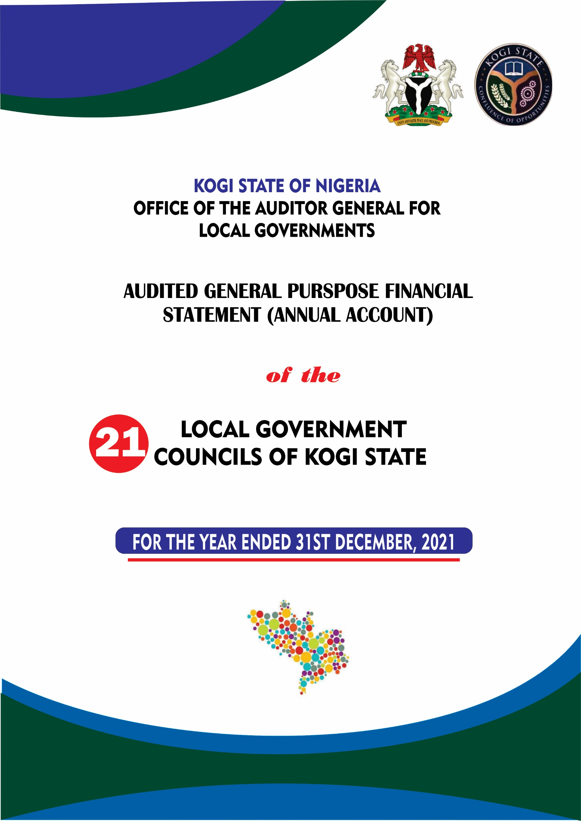

**AUDITED GENERAL PURPOSE FINANCIAL STATEMENTS**

**(ACCRUAL BASED)**

**OF THE**

**21 LOCAL GOVERNMENT COUNCILS OF KOGI STATE**

**FOR THE YEAR ENDED 31ST DECEMBER, 2021**

**PRESENTED TO**

**KOGI STATE HOUSE OF ASSEMBLY**

**BY**

**AUDITOR-GENERAL FOR LOCAL GOVERNMENT**

**Alh. Usman Ododo B.Sc., ACA, CPFA, MNIN**

**JUNE, 2022**

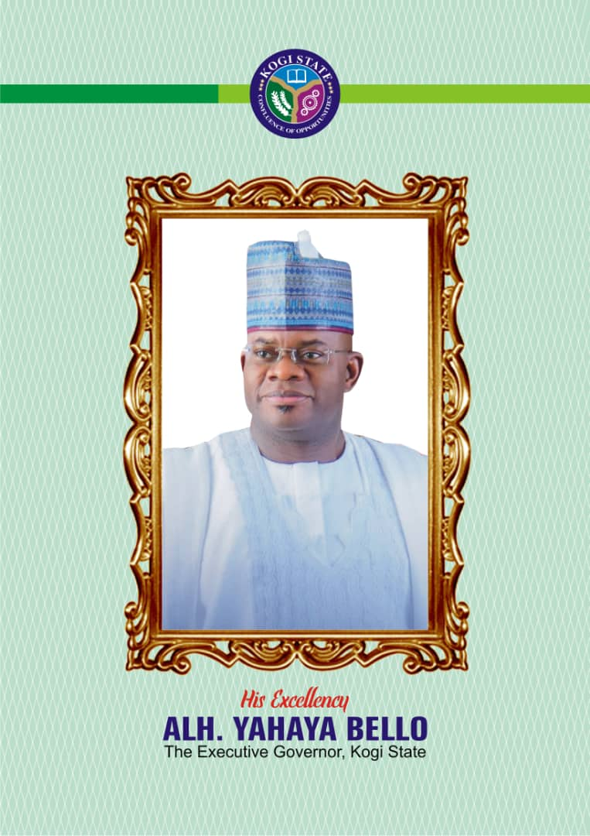

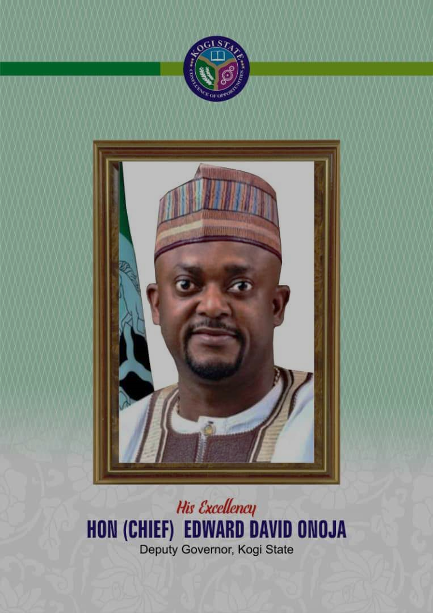

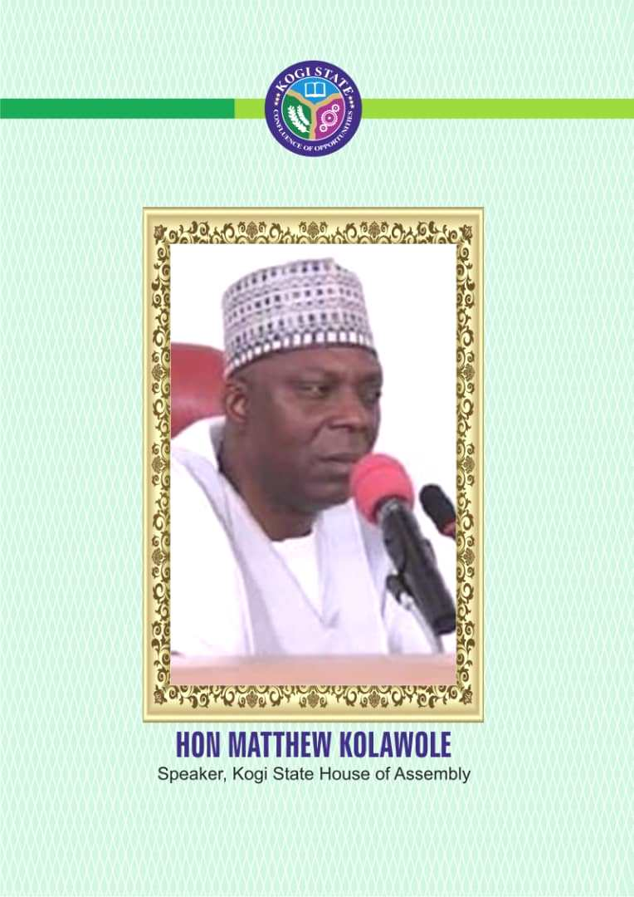

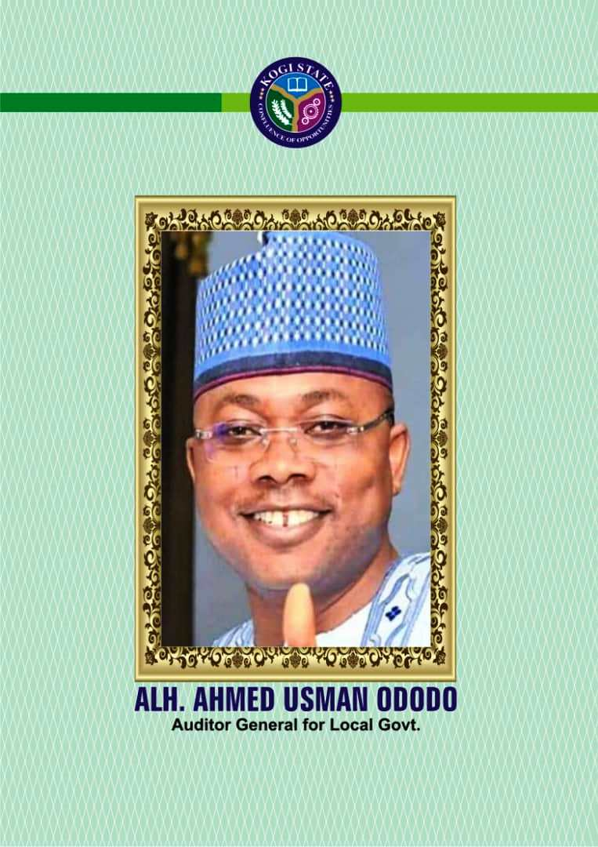

**TABLE OF**

**CONTENT**

**Pages**

Table of Contents i

Report of the Auditor-General for Local Government ii

Financial Statement of Adavi Local Government Council 1 - 18

Financial Statement of Ajaokuta Local Government Council 19 - 36

Financial Statement of Ankpa Local Government Council 37 - 58

Financial Statement of Bassa Local Government Council 59 - 74

Financial Statement of Dekina Local Government Council 75 - 94

Financial Statement of Ibaji Local Government Council 95 - 114

Financial Statement of Idah Local Government Council 115 - 134

Financial Statement of Igalamela/Odolu Local Government Council 135 - 154

Financial Statement of Ijumu Local Government Council 155 - 174

Financial Statement of Kabba Bunu Local Government Council 175 - 196

Financial Statement of Kogi Local Government Council 197 - 214

Financial Statement of Lokoja Local Government Council 215 - 234

Financial Statement of Mopa-Muro Local Government Council 235 - 254

Financial Statement of Ofu Local Government Council 255 - 274

Financial Statement of Ogori-Magongo Local Government Council 275 - 296

Financial Statement of Okehi Local Government Council 297 - 314

Financial Statement of Okene Local Government Council 315 - 334

Financial Statement of Olamaboro Local Government Council 335 - 356

Financial Statement of Omala Local Government Council 357 - 374

Financial Statement of Yagba East Local Government Council 375 - 392

Financial Statement of Yagba West Local Government Council 393 – 410

**Audit Certificate**

**Report of the Auditor general For Local Government, Kogi State on the financial statement of the 21 Local government Councils, Kogi State for the Year Ended 31 December 2021.**

In accordance with relevant section of the Constitution of the Federal Republic of Nigeria, 1999 as amended and Local Government Audit Law 2021, I have audited the Accounts and Financial Statements of the 21 Local Government Councils, Kogi State, for the year ended 31st December, 2021, which has been prepared in accordance with the requirements of the International Public Sector Accounting Standards (IPSAS), Financial Reporting Council (FRC) and other relevant Laws, rules and regulations.

**Auditor-General for Local Government Responsibility**

The responsibility of the Auditor General is to express an opinion on the financial statement of the 21 Local Government Council based on the audit conducted in accordance with the auditing standards as specified in the Kogi State Local Government Audit Laws 2021, and in accordance with the requirements of the International Standards on Auditing.

**Basis of Opinion**

We carried out the audit in line with the requirements of the International Standards on Auditing (ISA) issued by the International Federation of Accountants (IFAC) through the International Auditing and Assurance Standards Board (IAASB), and also in consonance with the advisories issued by International Organization of Supreme Audit Institutions (INTOSAI). Accordingly, the audits were planned and performed and all information and explanation considered necessary to provide reasonable assurance were obtained to ensure that the financial statements are free from material misstatements.

**Opinion**

In my opinion, the financial statements of the 21 Local Governments Councils of Kogi State for the year ended 31st December, 2021 show a true and fair view of the state of affairs, the cash flow and the financial position as at that date.

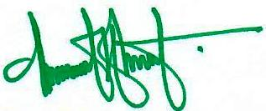

___________________________________

**Alh. Usman Ododo B.Sc., ACA, CPFA, MNIN**

*The Auditor-General*

*for Local Government,*

*Kogi State.*

