

**IDAH LOCAL GOVERNMENT OF**

**KOGI STATE**

**AUDITED FINANCIAL STATEMENTS**

**FOR**

**THE YEAR ENDED 31 DECEMBER 2018**

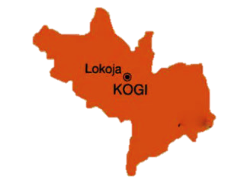



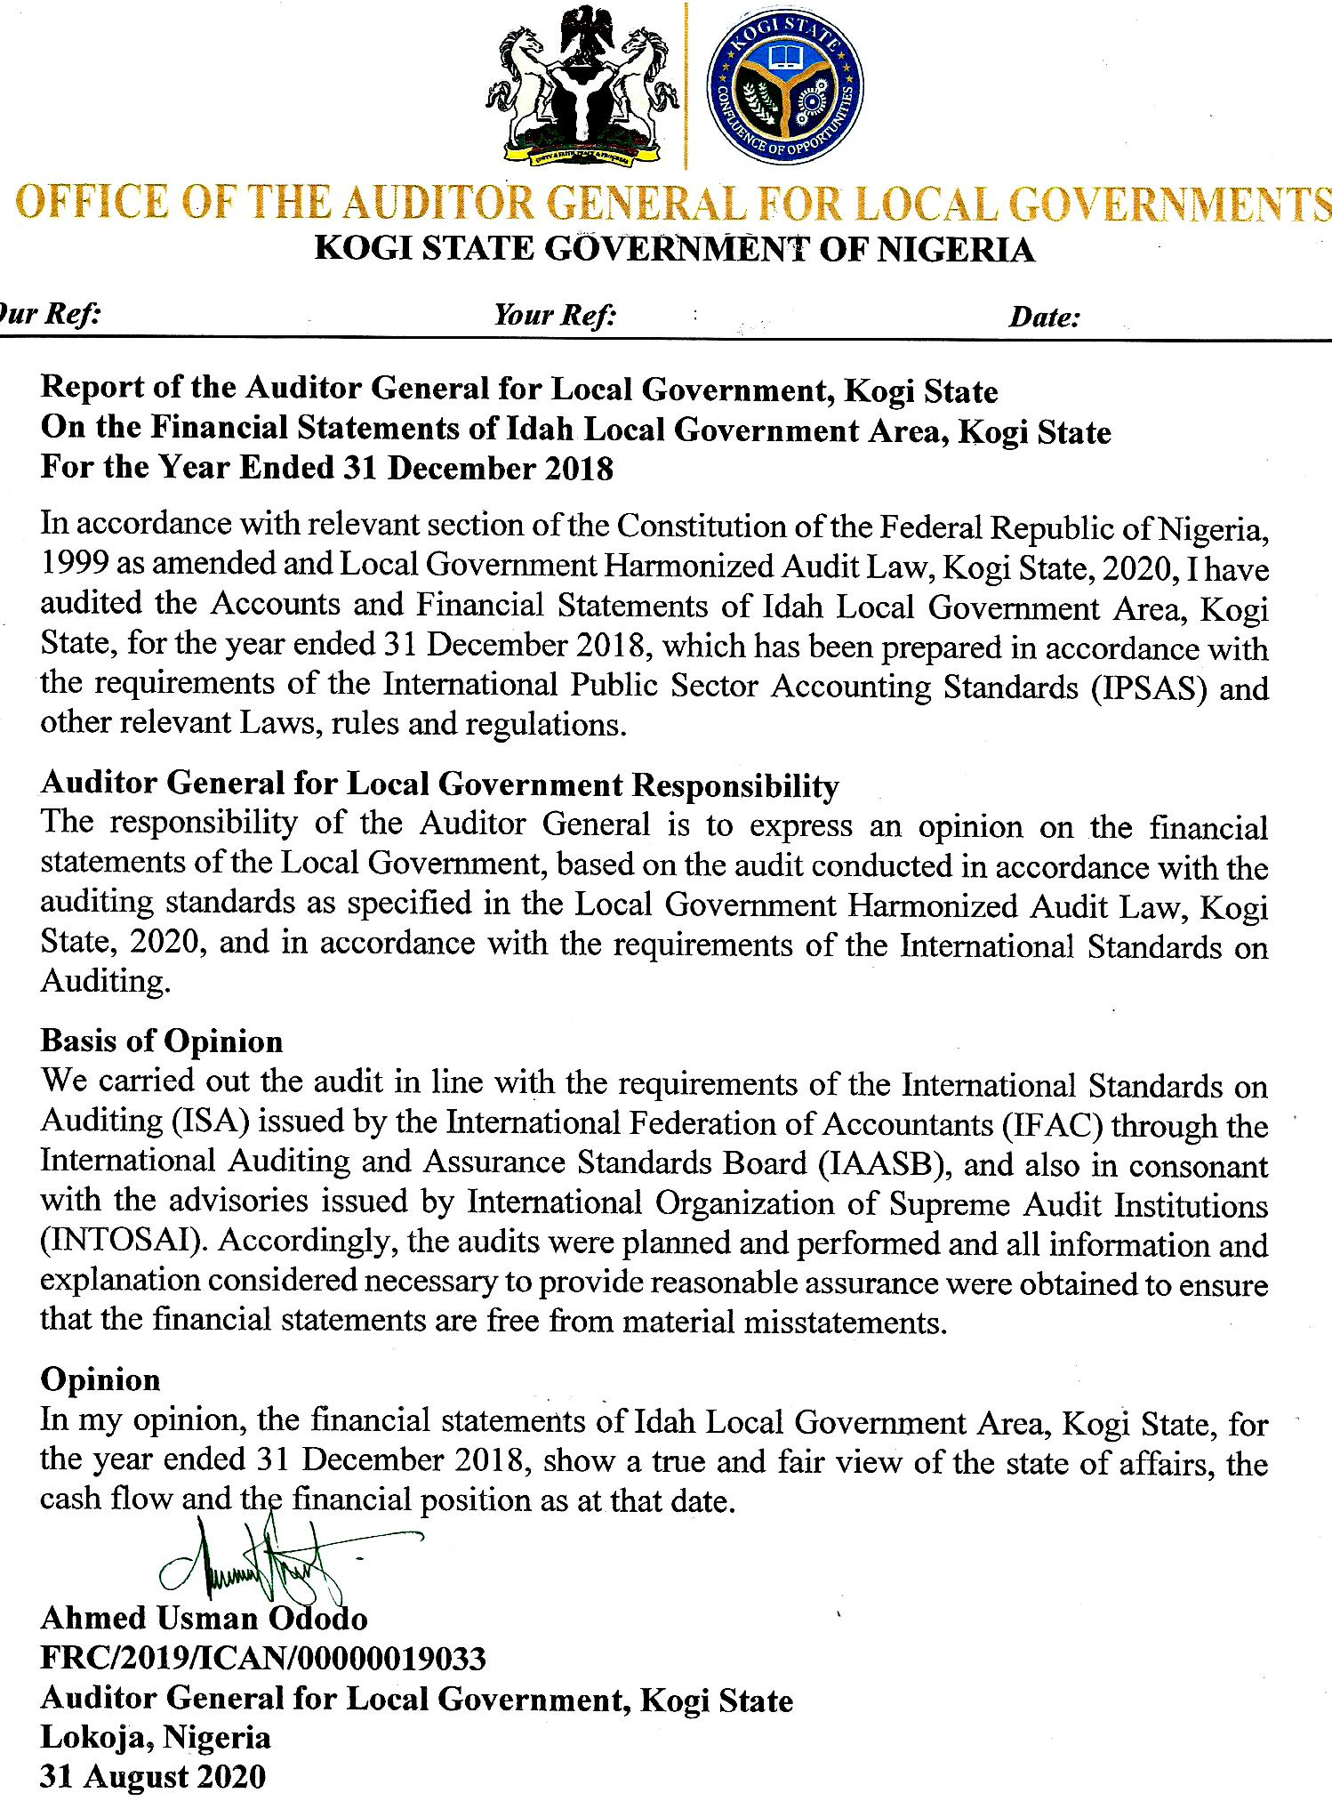

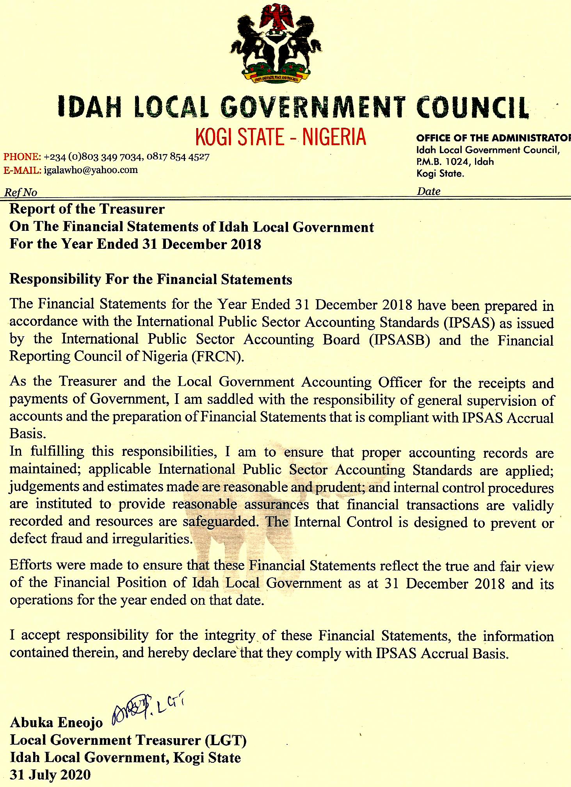

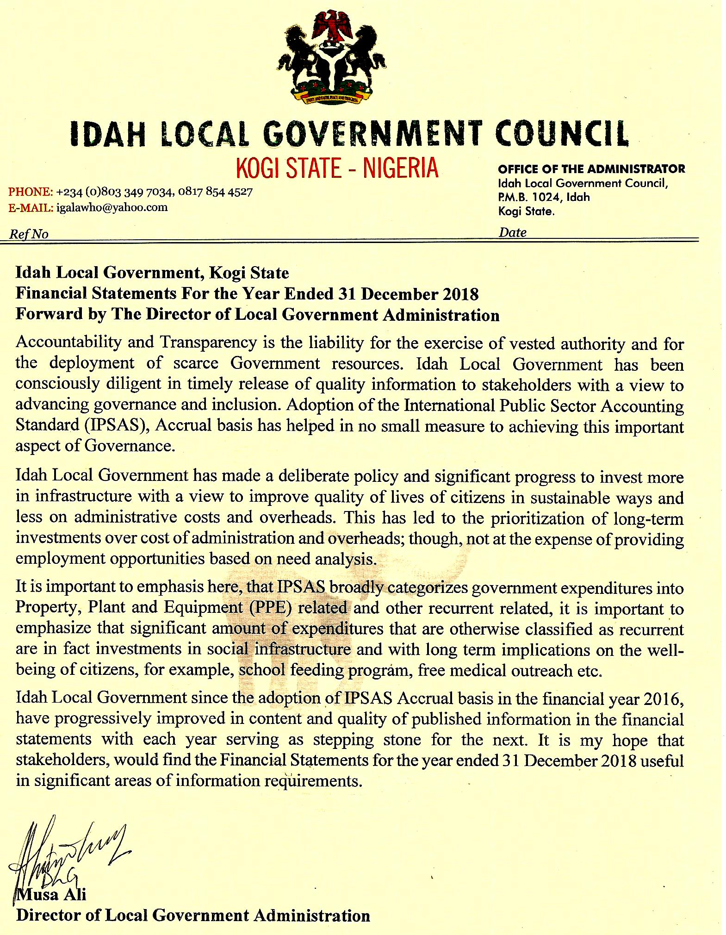

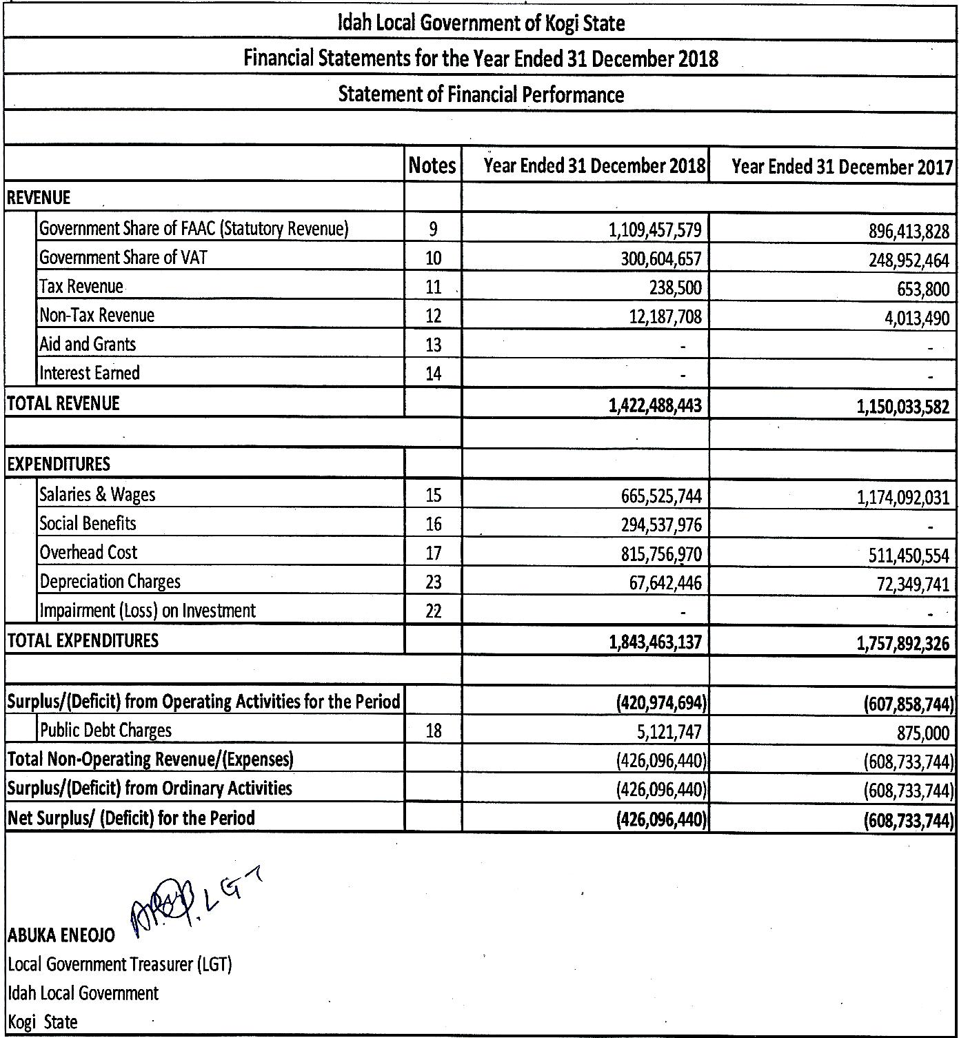

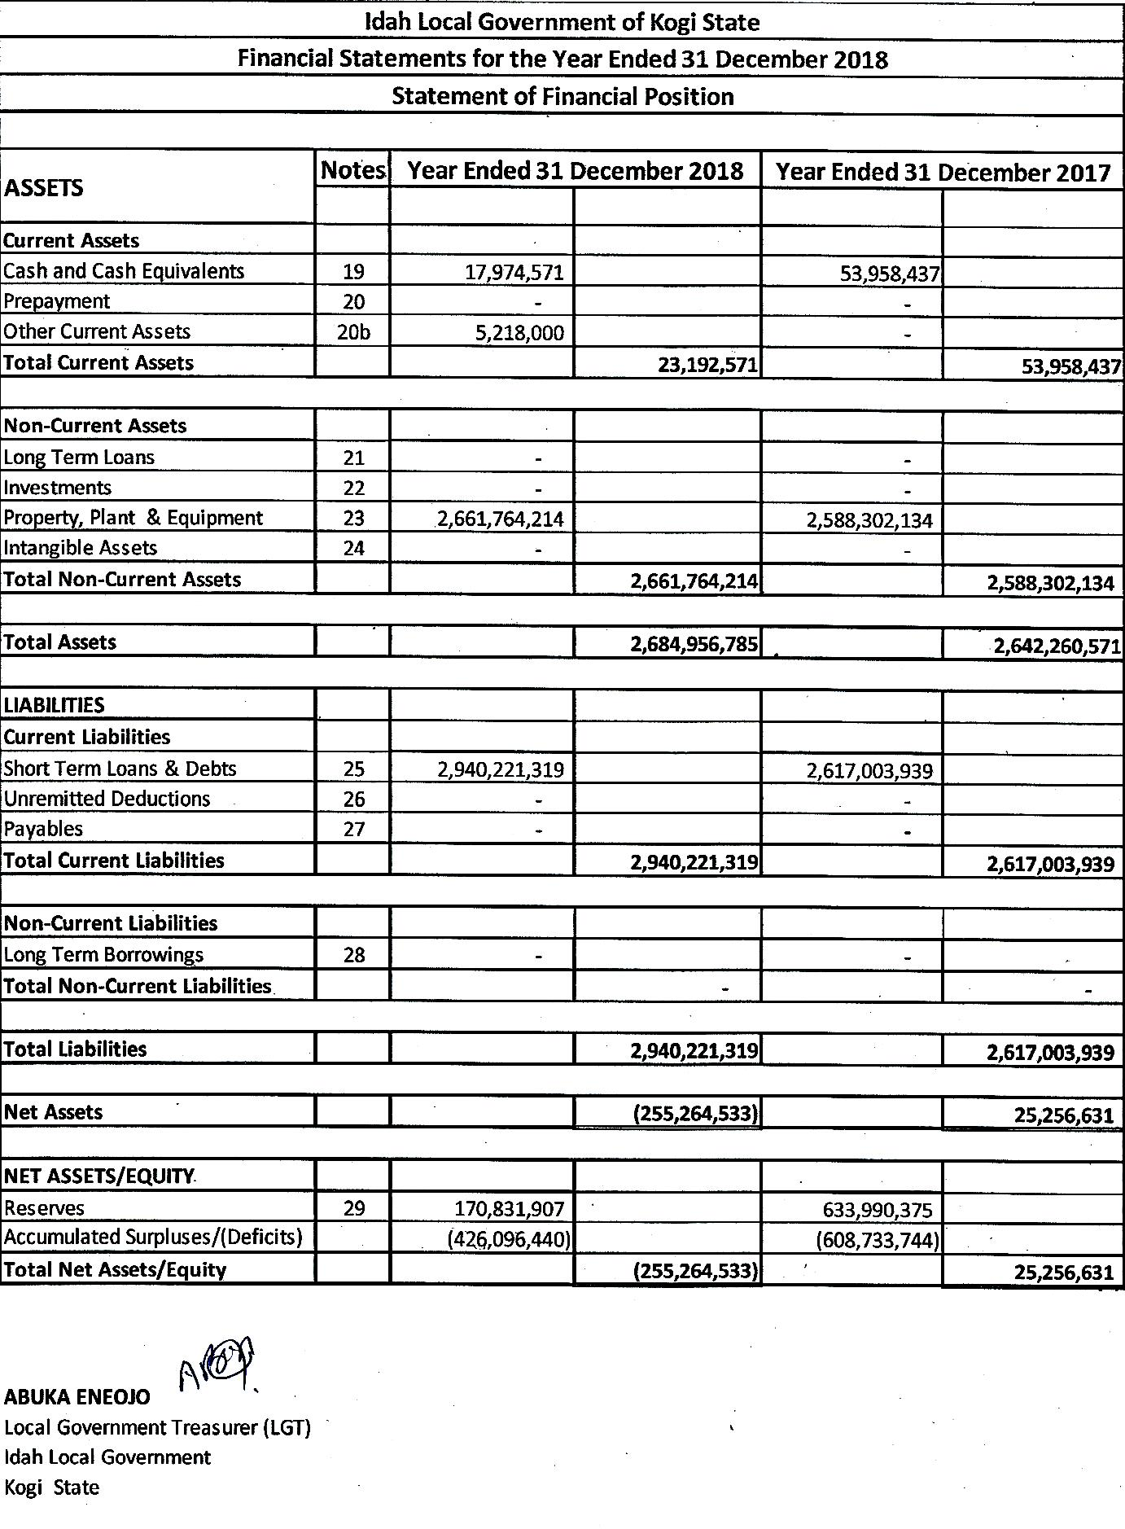

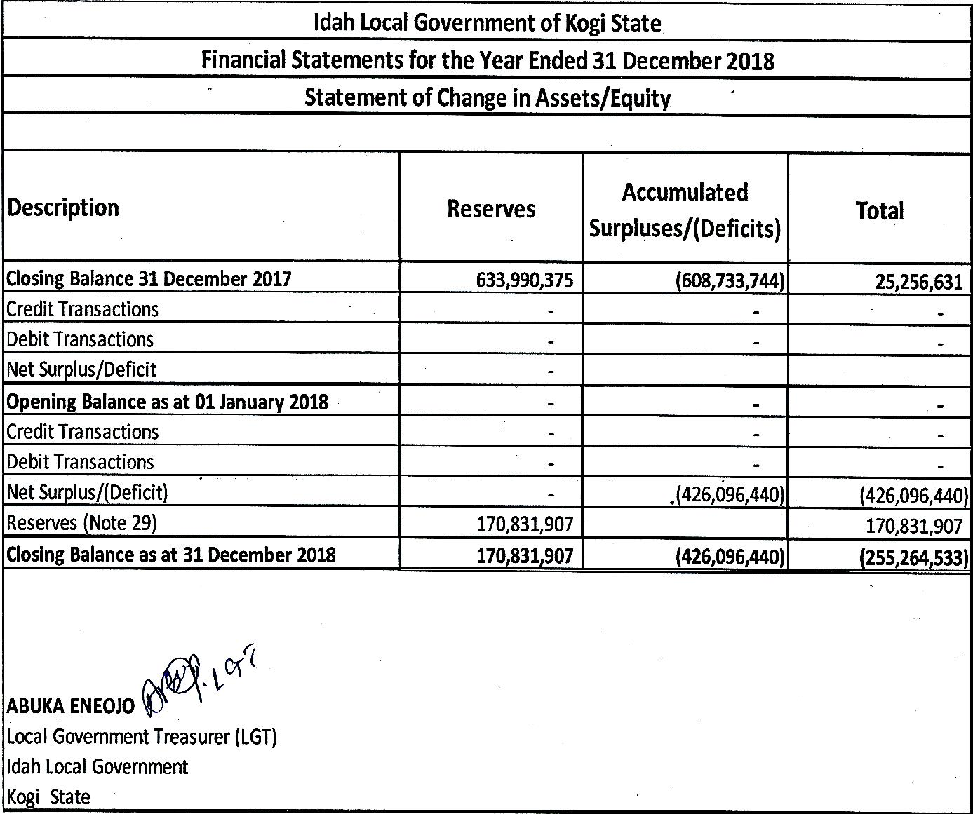

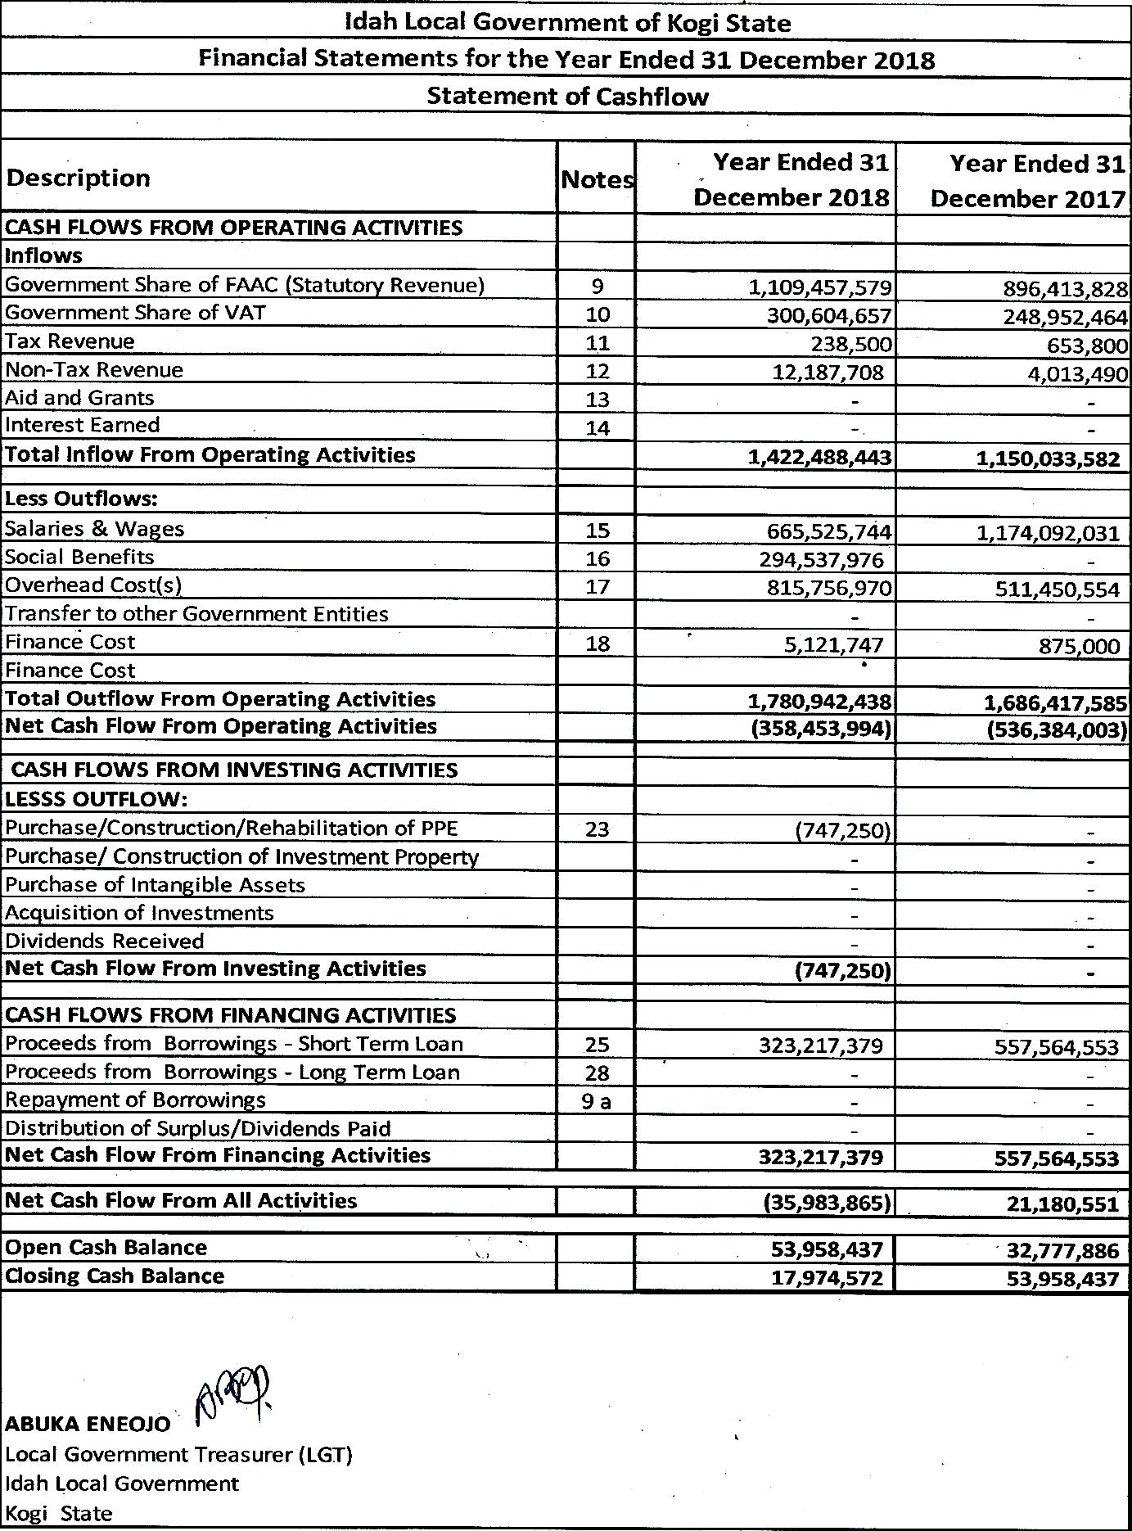

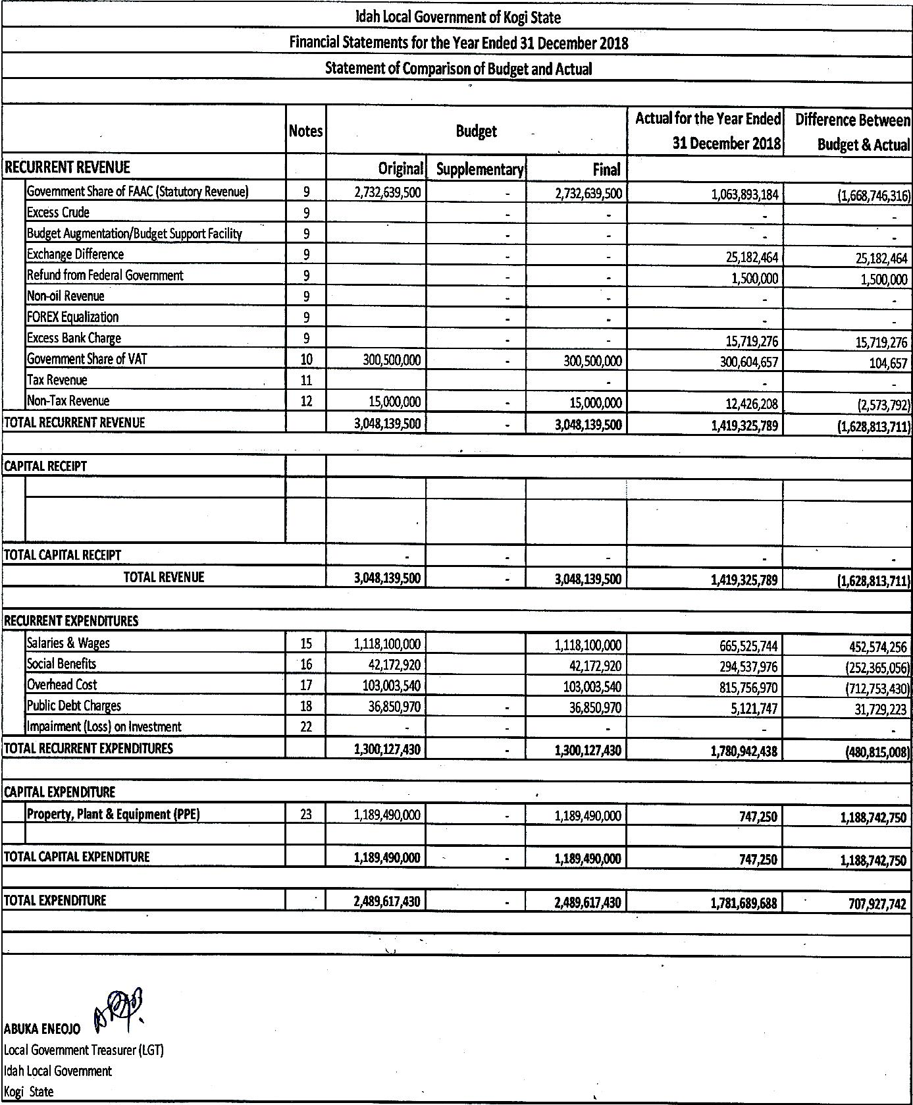



**Idah Local Government of Kogi State**

**Financial Statements for the Year Ended 31 December 2018**

**Notes to the Financial Statements**

**1. Introduction**

In compliance with Section 101 of the Financial Regulation as well as Provision of the Finance (Control and Management) Act 1958, now CAP F.26 LFN 2004, I have the honour and privilege to present the report on the accounts of the Idah Local Governments of Kogi State for the financial year ended 31 December 2018, together with the notes thereon. The preparations have been made to comply with the provisions of International Public Sector Accounting Standards (IPSAS) Accrual Basis of Accounting.

**2. Legal Basis and Accounting Framework**

These Financial Statements have been prepared in accordance with the provisions of the Finance (Control and Management) Act 1958 now CAP F26 LFN 2004 as well as the National Treasury Circular TRY/A5 & **B5/2016.OAGF/CAD/26/V.III/7**. The Statements comply with the provisions of International Public Sector Accounting Standards (IPSAS) Accrual Basis, issued by the International Public Sector Accounting Standard Board (IPSASB) for the three tiers of government in Nigeria.

In accordance with the provisions of Finance (Control and Management) Act, 1958 and Section 101 of Financial Instruction (FI), the Accountant-General is responsible for the preparation of Financial Statements. The Treasurer is the Chief Accounting Officer for the receipts and payments of Idah Local Government. He is responsible for the general supervision of accounting activities in all Departments within the Idah Local Government and for compilation of the Annual Financial Statements of Accounts and of such other Statements of Accounts as may be required by law.

**Idah Local Government of Kogi State**

**Financial Statements for the Year Ended 31 December 2018**

**Notes to the Financial Statements**

In discharging this statutory responsibilities, he;

1. Ensures that all Ministries, Departments and Agencies keep proper books and records which disclose with reasonable assurance and accuracy of the financial position of the State.
2. Takes such steps as are reasonably open to him to safeguard the assets of the State and to prevent and detect fraud and irregularities
3. Establishes and maintain an adequate system of internal control designed to provide reasonable assurance that the transactions recorded reflect the deployment of all financial resources by Idah Local Government
4. Ensures that in preparing the financial statements, he uses appropriate accounting policies consistently and supported by reasonable and prudent judgments and estimates and that all applicable accounting standards have been followed.

**3. Basis of Preparation**

**a) Statement of Compliance**

In line with the recommendation of FAAC, for the adoption of IPSAS-Accrual Accounting for all Public Sector Entities (PSE) in Nigeria with effect from 01 January 2016, the Kogi State Governments transits from the IPSAS Cash-Basis of accounting to Accrual Basis of accounting as first time adopter in 2016, and subsequently maintains such.

**Idah Local Government of Kogi State**

**Financial Statements for the Year Ended 31 December 2018**

**Notes to the Financial Statements**

The Adoption of Accrual Basis of accounting helps in the assessment of financial performance as the financial statements reflect all expenses whether paid or not and all income whether received or not, together with the comprehensive information on the financial position (i.e. assets and liabilities) and the Changes in Net Equity of the State Government. To this end, a Standardized Chart of Account (COA) along-side a set of General Purpose Financial Statements (GPFS) was domesticated and adopted.

**b) Basis of measurement**

The General Purpose Financial Statements (GPFS) are prepared under the Historical cost convention and in accordance with the International Public Sector Accounting Standards (IPSAS) Accrual Basis and other applicable Standards as defined by the Fiscal Responsibility Commission (FRC), the Financial Reporting Council of Nigeria (FRCN) and with the provisions of the Constitution of the Federal Republic of Nigeria 1999 as amended, the Finance Control and Management Act (1958) now CAP F.26 LFN 2004 and in agreement with the Standardized Reporting Format approved by the Federation Account Allocation Committee (FAAC) of the Federal Republic of Nigeria in 2013.

In order to ensure effective and efficient utilization of the COA and the GPFS, Accounting Policies have been developed by the Idah Local Government as a set of Guidelines to direct the processes and procedures relating to financial reporting in the State Government financial statements.

**Idah Local Government of Kogi State**

**Financial Statements for the Year Ended 31 December 2018**

**Notes to the Financial Statements**

Thus, in line with the Format, the 2018 Consolidated Financial Statements comprise of the following;-

1. Consolidated Statement of Financial Performance,
2. Consolidated Statement of Cash-Flow Statement,
3. Consolidated Statement of Financial Position,
4. Consolidated Statement of Changes in Equity,
5. Consolidated Statement of Comparison of Budget and Actual,
6. Notes to the Financial Statements
7. Accounting Policies and other explanatory statements or notes.
8. **Presentation Currency**

All amounts have been presented in the currency of the Nigeria Naira (₦) which is the functional currency of Idah Local Government of Kogi State**.**

1. **Going Concern**

The financial statements have been prepared on a Going Concern Basis.

**4. Accounting Principles**

The objectives of the financial statements are to provide information about the financial position, performance and cash flows of Idah Local Government of Kogi State that is useful to a wide range of users. Being a public sector entity, the objectives were developed specifically to provide information useful for decision making, and also to demonstrate the level of Idah Local Government of Kogi State accountability for the resources entrusted to it.

**Idah Local Government of Kogi State**

**Financial Statements for the Year Ended 31 December 2018**

**Notes to the Financial Statements**

The key considerations and accounting principles to be followed when preparing the financial statements are those laid out in Kogi State Government’s Financial Regulations and Public Finance Management Law (2011) and those described in IPSAS1. This includes: fair presentation, accrual basis, going concern, consistency of presentation, aggregation, offsetting and comparative information.

Preparation of the financial statements in accordance with the above mentioned rules and principles requires management to make estimates that affect the reported amounts of certain items in the Statement of financial position and Statement of financial performance (economic outturn account), as well as the related disclosures.

**5. Accounting Period**

The Accounting year of the Idah Local Government Financial Statements (Fiscal year) is from 01 January to 31 December. Each accounting year is divided into 12 Calendar months (Periods) and is set up as such in the accounting system.

**6. Summary of Significant Accounting Policies**

Idah Local Government of Kogi State has applied the following accounting policies in preparation of the financial statements for the year ended 31 December 2018. These policies have been consistently applied to all the years presented, unless otherwise stated.

**Idah Local Government of Kogi State**

**Financial Statements for the Year Ended 31 December 2018**

**Notes to the Financial Statements**

6.1 **Revenue**

Revenue includes only the gross inflow of economic benefits or service potential received or is receivable by the entity on its own account. Those amounts collected as an agent of the government or on behalf of third parties are not considered as revenue. Revenue is measured at the fair value of the consideration received or receivable.

1. **Revenue from Non-exchange Transactions**

These are transactions in which Idah Local Government of Kogi State receives value from, without directly giving appropriately equal value in exchange. This includes mainly direct and indirect taxes. In addition to taxes, Idah Local Government of Kogi State also receives payments from other parties, such as transfers, grants, fines and donations.

1. **Taxes Receipts**

Taxes are economic benefits or service potential compulsorily paid or payable to Idah Local Government of Kogi State, in accordance with laws and/or regulations, established to provide revenue to the Idah Local Government. Taxes do not include fines or other penalties imposed for breach of the law. Idah Local Government of Kogi State recognizes revenue from taxes by reference to the earning of assessable income by the taxpayers. Taxes are measured at the fair value of the consideration received or receivable to Idah Local Government of Kogi State Inland Revenue Service. The tax rates and tax laws used to compute the amount are those that are enacted or substantively enacted, at the reporting date.

**Idah Local Government of Kogi State**

**Financial Statements for the Year Ended 31 December 2018**

**Notes to the Financial Statements**

Idah Local Government of Kogi State taxes include: Hawkers’ Permit, Abattoir/Slaughter permit Licenses, Birth & Death Registration fee, Parking Space fees and other tax receipts.

1. **Levies, Fees and Fines**

These are inflows of future economic benefits or service potentials from non-exchange transactions other than taxes. They are economic benefits or service potential received or receivable by Idah Local Government of Kogi State, as determined by Kogi State laws or by a court and other law enforcement bodies, as a consequence of the breach of laws or regulations and are recognized at the point when the levy is being imposed.

1. **Statutory Allocation**

Statutory allocation is income from the revenue allocation system wherein funds are allocated to each federating unit from the Federation Account based on certain predetermined criteria. Statutory allocation is measured at fair value and recognized at point of receipt.

1. **Capital Receipts**

These include grants and other capital receipts. Capital receipts are measured at fair value or when there is an enforceable claim to receive the asset if it is free from conditions. Capital receipts are recognized when it is probable that the economic benefits or service potential related to the asset will flow to Kogi State Government and can be measured reliably.

**Idah Local Government of Kogi State**

**Financial Statements for the Year Ended 31 December 2018**

**Notes to the Financial Statements**

1. **Other Revenue from Non-Exchange Transactions**

These represent revenue from Lottery Board and recovered funds. Revenue from Lottery Board is received from lottery and bet operators in the State. This is recognized at the fair value of the consideration received or receivable.

1. **Revenue From Exchange Transactions**

These are transactions in which Idah Local Government receives consideration from, and directly gives approximately equal value in revenue from the sale of goods and services is recognized when the significant risk and rewards of ownership of the goods are transferred to the buyer. This is when the goods have been delivered and when the revenue can be measured reliably and it is probable that the economic benefits or service potential associated with the transaction will flow to Idah Local Government .

Revenue involving the provision of services is recognized by reference to the stage of completion of the transaction at the reporting date.

Revenue arising from the use by others of Idah Local Government’s assets yielding rental income, interest, royalties and dividends or similar distributions, are recognized as they are earned in accordance with the substance of the relevant agreement. Revenue is recognized when the amount can be measured reliably, and it is probable that the economic benefits or service potential associated with the transaction will flow to Idah Local Government. Where the contract outcome cannot be measured reliably, revenue is recognized only to the extent that the expenses incurred are recoverable.

**Idah Local Government of Kogi State**

**Financial Statements for the Year Ended 31 December 2018**

**Notes to the Financial Statements**

1. **Revenue From Other Services**

Revenue from other services include proceeds from Private Sector Developer’s Programme, toll revenue, proceeds from hospital units and other miscellaneous revenue from exchange transactions. Idah Local Government recognizes revenue from rendering of services as it is earned, that is, as the services are provided. It is measured at the fair value of the consideration received or receivable.

1. **Investment Income**

Investment income consists of dividend income. Dividend income or similar distributions are recognized when Idah Local Government’s right to receive payment is established.

**6.2 Public Debt Charges**

Interest cost is calculated using the Effective Interest Rate Method. The effective yield discounts estimated future cash receipts through the expected life of the financial asset to that asset’s net carrying amount. The method applies this yield to the principal outstanding to determine interest income / cost for each period.

**6.3 Cash and cash equivalent**

Cash and cash equivalents as shown in the statement of financial position comprises cash-in-hand or bank, deposit held at call with financial institutions and other short-term, highly liquid investments with original maturities of three months or less that are readily convertible to known amounts of cash and which are subject to an insignificant risk of changes in value.

**Idah Local Government of Kogi State**

**Financial Statements for the Year Ended 31 December 2018**

**Notes to the Financial Statements**

**6.4 Inventory**

Inventories are stated at the lower of cost, current replacement cost and net realizable value. Net realizable value is the estimated selling price in the ordinary course of business, less any applicable completion and selling expenses. When inventories are held for distribution at no charge or for a nominal charge, they are measured at the lower of cost and current replacement cost. Current replacement cost is the cost that the Idah Local Government would incur to acquire the asset on the reporting date.

The cost of finished goods and work in progress is determined using the first-in, first-out (FIFO) method and comprises raw materials, direct labour, other direct costs and related production overheads (based on normal operating capacity), incurred in bringing inventory to its present location and condition but, excludes borrowing.

**6.5 Financial Instrument**

A financial instrument is any contract that gives rise to both a financial asset of one entity and a financial liability or equity instrument of another entity.

Idah Local Government classifies its financial assets in the following categories: at fair value through surplus or deficit, held to maturity, loans and receivables, and available for sale. The classification depends on the purpose for which the financial assets were acquired.

Idah Local Government classifies its financial liabilities at fair value through surplus or deficit and at amortized cost. Classification of financial liabilities is based on the nature or characteristic of the instrument. The Office of the Accountant-General determines the classification of its financial assets and liabilities at initial recognition.

For the fourth Transitional Financial Statements for the year ended 31 December 2018, Idah Local Government has recognized financial liabilities measured at amortized cost. These include Idah Local and foreign debts and investments.

**Idah Local Government of Kogi State**

**Financial Statements for the Year Ended 31 December 2018**

**Notes to the Financial Statements**

1. **Classification**
2. **Financial Assets and Liabilities at Fair Value through Surplus or Deficit**

Financial assets or liabilities at fair value through surplus or deficit are financial assets or liabilities held for trading. A financial asset or liability is classified in this category if: acquired principally for the purpose of selling or repurchasing in the short term; or on initial recognition, it is part of a portfolio of identified financial instruments that are managed together and for which there is evidence of a recent pattern of short-term profit taking. Assets in this category are classified as current assets if expected to be realized within twelve months; otherwise, they are classified as non-current assets.

1. **Loans and Receivables**

Loans and receivables are non-derivative financial assets with fixed or determinable payments that are not quoted in an active market. They are included in current assets, except for maturities greater than twelve months after the end of the reporting period. These are classified as non-current assets. Idah Local Government's loans and receivables comprise ‘receivables from exchange transactions', 'recoverable from non-exchange transactions', 'other receivables’ and ‘cash and cash equivalents’ and are presented in the statement of financial position.

**Idah Local Government of Kogi State**

**Financial Statements for the Year Ended 31 December 2018**

**Notes to the Financial Statements**

1. **Available-for-sale Investments**

Available-for-sale financial assets are non-derivatives that are either designated in this category or not classified in any of the other categories. They are included in non-current assets unless the investment matures or Idah Local Government intends to dispose of it within 12 months of the end of the reporting period. Idah Local Government has recognized some of its quoted and unquoted investments as well as managed funds as available-for-sale Investment.

1. **Financial Liabilities at Amortized Cost**

Financial Liabilities at amortized cost include Payables, Other Liabilities and Debts

1. **Categories & Measurement**
2. **Financial Asset or Financial Liability at Fair Value through Surplus or Deficit**

Financial instruments in this category are measured at fair value on both initial recognition and subsequently. Transaction costs are expensed in the statement of financial performance. Surplus and deficit arising from changes in fair value are presented in the statement of financial performance within “other surplus and deficit (net)” in the period in which they arise. Non-derivative financial assets and liabilities at fair value through surplus or deficit are classified as current except for the portion expected to be realized or paid beyond twelve months of the reporting date, which are classified as long-term.

**Idah Local Government of Kogi State**

**Financial Statements for the Year Ended 31 December 2018**

**Notes to the Financial Statements**

1. **Loan & Receivables**

Loans and receivables are initially recognized at fair value less transaction costs. Subsequently, loans and receivables are measured at amortized cost using the effective interest method less a provision for impairment.

1. **Available for Sale Investments**

Available-for-sale investments are recognized initially at fair value plus transaction costs and are subsequently carried at fair value. A gain or loss on an available-for-sale financial asset shall be recognized directly in net assets through the Statement of changes in net assets, except for impairment losses and foreign exchange gains and losses, until the financial asset is derecognized, at which time the cumulative gain or loss previously recognized in net assets shall be recognized in surplus or deficit. On the other hand, interest calculated using the effective interest method is recognized in surplus or deficit. Available-for-sale investments are classified as non-current asset, unless an investment matures within twelve months, or the Government expects to dispose of it within twelve months.

1. **Financial Liabilities at Amortized Cost**

Financial liabilities measured at amortized cost are recognized initially at fair value, net of any transaction costs incurred, and subsequently at amortized cost using the effective interest method. These are classified as current liabilities if payment is due within twelve months. Otherwise, they are presented as non-current liabilities.

**Idah Local Government of Kogi State**

**Financial Statements for the Year Ended 31 December 2018**

**Notes to the Financial Statements**

1. **Recognition & De-recognition**

Financial instruments are recognized when Idah Local Government becomes a party to the contractual provisions of the instrument. Planned future transactions, no matter how likely their occurrence may be, are not assets and liabilities because the entity has not become a party to a contract. Financial assets are derecognized when the rights to receive cash flows from the assets have expired or have been transferred and Idah Local Government has transferred substantially all risks and rewards of ownership. Financial liabilities are derecognized when the obligation under the liability is discharged, cancelled or expired.

1. **Reclassification**

Idah Local Government may choose to reclassify a non-derivative trading financial asset out of the held for trading category if the financial asset is no longer held for the purpose of selling it in the near term. Financial assets other than loans and receivables are permitted to be reclassified out of the held for trading category only in rare circumstances arising from a single event that is unusual and highly unlikely to recur in the near term. Reclassifications are made at fair value as of the reclassification date. Fair value becomes the new cost or amortized cost as applicable, and no reversals of fair value gains or losses recorded before reclassification date are subsequently made.

**Idah Local Government of Kogi State**

**Financial Statements for the Year Ended 31 December 2018**

**Notes to the Financial Statements**

1. **Offsetting Financial Instruments**

Financial assets and liabilities are offset and the net amount reported in the statement of financial position when there is a legally enforceable right to offset the recognized amounts and there is an intention to settle on a net basis or realize the asset and settle the liability simultaneously. The legally enforceable right must not be contingent on future events and must be enforceable in the normal course of business.

1. **Impairment of financial assets**

Idah Local Government assesses at the end of each reporting period whether there is objective evidence that a financial asset or group of financial assets are impaired. A financial asset or a group of financial assets is impaired and impairment losses are incurred only if there is objective evidence of impairment as a result of one or more events that occurred after the initial recognition of the asset (a ‘loss event’) and that loss event (or events) has an impact on the estimated future cash flows of the financial asset or group of financial assets that can be reliably estimated.

Evidence of impairment may include indications that the debtors or a group of debtors is experiencing significant financial difficulty, default or delinquency in interest or principal payments, the probability that they will enter bankruptcy or other financial reorganization, and where observable data indicate that there is a measurable decrease in the estimated future cash flows, such as changes in arrears or economic conditions that correlate with defaults.

**Idah Local Government of Kogi State**

**Financial Statements for the Year Ended 31 December 2018**

**Notes to the Financial Statements**

For loans and receivables category, the amount of the loss is measured as the difference between the asset’s carrying amount and the present value of estimated future cash flows (excluding future credit losses that have not been incurred) discounted at the financial asset’s original effective interest rate.

The carrying amount of the asset is reduced and the amount of the loss is recognized in the statement of financial performance. If a loan or held-to-maturity investment has a variable interest rate, the discount rate for measuring any impairment loss is the current effective interest rate determined under the contract.

As a practical expedient, Idah Local Government may measure impairment on the basis of an instrument’s fair value using an observable market price. If, in a subsequent period, the amount of the impairment loss decreases and the decrease can be related objectively to an event occurring after the impairment was recognized (such as an improvement in the debtor’s credit rating), the reversal of the previously recognized impairment loss is recognized in the statement of financial performance.

1. **Financial Instruments denominated in foreign currencies**

These are financial instruments denominated in a currency other than the functional currency that results in the contractual right to collect, or contractual obligation to deliver cash in foreign currencies such as external loans where the amounts payable or receivable are denominated in a foreign currency.

**Idah Local Government of Kogi State**

**Financial Statements for the Year Ended 31 December 2018**

**Notes to the Financial Statements**

Financial instruments denominated in a foreign currency are initially recognized in the functional currency, by applying to the foreign currency amount, the Spot Exchange Rate between the functional currency and the foreign currency at the date of the transaction. At each subsequent reporting date, these financial instruments are translated using the closing rate.

**6.6 Property, Plant & Equipment (PPE)**

Idah Local Government performed an Asset Verification Exercise in order to determine the deemed cost of some PPE items as at the date of adoption of IPSAS. Recognition of PPE items will be on a class by class basis.

Property, Plant and Equipment are stated at historical cost less accumulated depreciation and impairment losses. Historical cost includes expenditure that is directly attributable to the acquisition or construction of the asset. Subsequent costs are included in the asset’s carrying amount or recognized as a separate asset, as appropriate, only when it is probable that future economic benefits or the service potentials, associated with the item will flow to Idah Local Government and its cost can be measured reliably.

Repairs and maintenance costs are charged to the statement of financial performance during the financial period in which they are incurred.

Finance costs attributable to amounts borrowed by Idah Local Government to fund the acquisition of property, plant and equipment are expensed immediately as they are incurred.

**Idah Local Government of Kogi State**

**Financial Statements for the Year Ended 31 December 2018**

**Notes to the Financial Statements**

Assets under construction are not depreciated as these assets are not yet available for use. Depreciation on other assets is calculated using the straight-line method to allocate their cost to their residual values over their estimated useful lives.

1. **Depreciation Rates**

The following standard rates shall be applied to all Idah Local Government assets:



Gains or losses on disposals are determined by comparing proceeds less selling expenses with the carrying amount of the disposed asset and are included in the Statement of financial performance.

**Idah Local Government of Kogi State**

**Financial Statements for the Year Ended 31 December 2018**

**Notes to the Financial Statements**

**6.7 Public Debt Charge**

Public debt charges are interest and other expenses incurred by Idah Local Government in connection with the borrowing of funds for qualifying assets. Idah Local Government has adopted the benchmark treatment, under which public debt charges are recognized as an expense in the period in which they are incurred, regardless of how the debts are applied.

**6.8 Impairment of Non-financial Asset**

Impairment is defined as a loss in the future economic benefits or service potential of an asset, over and above the systematic recognition of the loss of the asset’s future economic benefits or service potential through depreciation. Idah Local Government assesses whether there is any indication that an asset may be impaired at each reporting date. If any such indication exists, Idah Local Government will estimate the recoverable amount of the asset. For intangible assets, irrespective of whether there is any indication of impairment, Idah Local Government will test its intangible asset with an indefinite useful life or an intangible asset not yet available for use for impairment annually by comparing its carrying amount with its recoverable amount. If there is an indication that an asset may be impaired, this may indicate that the remaining useful life, the depreciation (amortization) method, or the residual value for the asset needs to be reviewed and adjusted in accordance with the standard applicable to the asset. If the reasons for impairments recognized in previous years no longer apply, the impairment losses are reversed accordingly. Recoverable amount is the higher of an asset’s fair value less costs to sell and its value in use. Impairment loss is recognized when the recoverable amount of an asset is less than its carrying amount. The carrying amount of the asset shall be reduced to its recoverable amount.

**Idah Local Government of Kogi State**

**Financial Statements for the Year Ended 31 December 2018**

**Notes to the Financial Statements**

An impairment loss shall be recognised immediately in surplus or deficit. After the recognition of an impairment loss, the depreciation (amortisation) charge for the asset shall be adjusted in future periods to allocate the asset’s revised carrying amount, less its residual value (if any), on a systematic basis over its remaining useful life

**6.9 Cash-generating Units**

A cash-generating unit is the smallest identifiable group of assets held with the primary objective of generating a commercial return that generates cash inflows from continuing use that are largely independent of the cash inflows from other assets or groups of assets. Identification of an asset’s cash-generating unit involves judgment. If recoverable amount cannot be determined for an individual asset, Idah Local Government will determine the recoverable amount of the cash-generating unit to which the asset belongs (the asset’s cash-generating unit).

**7.0 Foreign Currency Transactions**

Items included in the financial statements of each of Idah Local Government’s entities are measured using the currency of the primary economic environment in which the entity operates (‘the functional currency’). The financial statements are presented in Nigerian Naira (NGN), which is Idah Local Government’s functional and presentation currency. Foreign currency transactions throughout the year are converted into Nigerian Naira at the ruling Central Bank of Nigeria (CBN) rate of exchange at the dates of the transactions. Foreign currency balances as at the year-end are valued at the exchange rates prevailing at that date.

**Idah Local Government of Kogi State**

**Financial Statements for the Year Ended 31 December 2018**

**Notes to the Financial Statements**

Monetary assets and liabilities denominated in foreign currencies are translated into Nigerian Naira on the basis of the exchange rates applicable at the reporting period. Foreign exchange gains and losses that relate to debts are presented within the finance cost in the statement of financial performance. All other foreign exchange gains and losses are presented in the statement of financial performance on a net basis within other income or other expenses. Non-monetary items that are measured at fair value in foreign currency are translated using the exchange rates at the date when the fair value was determined. Translation differences on assets and liabilities carried at fair value are reported as part of the fair value gain or loss.

**8. Significant Accounting Judgement, Estimates & Assumptions**

1. **Contingent Assets**

A contingent asset is a possible asset that arises from past events and of which the existence will be confirmed only by the occurrence or non-occurrence of one or more uncertain future events not wholly within the control of Idah Local Government. A contingent asset is disclosed when an inflow of economic benefits or service potential is probable.

1. **Contingent Liabilities**

A contingent liability is a possible obligation that arises from past events and of which the existence will be confirmed only by the occurrence or non-occurrence of one or more uncertain future events not wholly within the control of the Idah Local Government, or a present obligation that arises from past events but is not recognised because:

**Idah Local Government of Kogi State**

**Financial Statements for the Year Ended 31 December 2018**

**Notes to the Financial Statements**

1. it is not probable that an outflow of resources embodying economic benefits or service potential will be required to settle the obligation or,
2. the amount of the obligation cannot be measured with sufficient reliability.

The preparation of Kogi State Government financial statements in conformity with IPSAS requires management to make judgements, estimates and assumptions that affect the reported amount of revenues, expenses, assets and liabilities, and the disclosure of contingent liabilities, at the end of the reporting period. However, uncertainty about these assumptions and estimates could result in outcomes that require a material adjustment to the carrying amount of the asset or liability affected in future periods.

1. **Estimation and Assumptions**

The preparation of financial statements in conformity with IPSAS requires the use of certain critical accounting estimates. It also requires management to exercise its judgement in the process of applying Idah Local Government’s accounting policies. The areas involving a higher degree of judgement or complexity, or areas where assumptions and estimates are significant to the financial statements are disclosed herein.

Estimates and judgements are continually evaluated and are based on historical experience and other factors, including expectations of future events that are believed to be reasonable under the circumstances. Idah Local Government makes estimates and assumptions concerning the future. The resulting accounting estimates will, by definition, seldom equal the related actual results.

**Idah Local Government of Kogi State**

**Financial Statements for the Year Ended 31 December 2018**

**Notes to the Financial Statements**

1. **Fair value estimation**

Where the fair value of financial assets and financial liabilities recorded in the statement of financial position cannot be derived from active markets, their fair value is determined using valuation techniques including the discounted cash flow model. The inputs to these models are taken from observable markets where possible, but where this is not feasible, judgment is required in establishing fair values. Judgment includes the consideration of inputs such as liquidity risk, credit risk, financial risk and volatility. Changes in assumptions about these factors could affect the reported fair value of financial instruments.

1. **Recoverable from Non-exchange Transactions**

A recoverable is recognized when revenue is earned but cash or its equivalent is yet to be received. In accordance with revenue recognition criteria, Idah Local Government has measured its recoverable arising from tax receipts by using statistical model based on the history of collecting the particular tax in prior periods.

1. **Depreciation and Carrying Amount of Property, Plant and Equipment**

The estimation of the useful lives of PPE is based on the state's accounting policy. Any material adjustment to the estimated useful lives of items of property, plant and equipment will have an impact on their carrying value.

1. **Leases**

Leases of property, plant and equipment where Idah Local Government, as lessee, has substantially all the risks and rewards of ownership are classified as finance leases. Finance leases are capitalized at the inception of the lease at the present value of the minimum lease payments.

**Idah Local Government of Kogi State**

**Financial Statements for the Year Ended 31 December 2018**

**Notes to the Financial Statements**

Each lease payment is allocated between the liability and finance charges so as to achieve a constant rate on the balance outstanding. The corresponding rental obligations, net of finance charges, are included in long term liabilities if the tenure is more than one year. The finance cost is charged to the profit or loss over the lease period so as to produce a constant periodic rate of interest on the remaining balance of the liability for each period.

Property, plant and equipment acquired under finance leases are depreciated on a straight-line basis over the asset's useful life or over the shorter of the asset's useful life and the lease term.



































